
Developing World Outreach Initiative (DWOI) and
Maquiladora Health & Safety Support Network (MHSSN)

Report:

The training workshops was done to workplace health and safety for dyeing and printing workers in Tiruppur district in the formal economic sector.

Groups targeted for training was workers in a dyeing and printing factory in where chemicals are used.

The training has motivated the workers to increase the OHS knowledge and skills of the participants towards handling the hazard chemicals in appropriate manner. The same workers were willing to educate and encourage other workers to follow the personal protective Equipment.

The project supposed to be completed in the previous year due to pandemic restriction we were unable to complete the task. The training workshop was done for 201 workers (189 males and 12 females).

Dyeing Worker Training - Programme Details
Date & Duration | Training/ Meeting/ Event | Title and Content | Resource Person's Name | Target Group/ Participants | Number of Participants  (excluding staff)
 |  |  |  |  | Male | Female | Total
04.04.2022 / An Hour | Shanthi Knit Finishers / KNP Colony | Occupational Health and Safety | R. Francis | Dyeing Workers | 21 | 0 | 21
04.04.2022 / 45 Mins | Sri Ramar Process / Kallikadu Thottam | Occupational Health and Safety | R. Francis | Dyeing Workers | 7 | 4 | 11
09.04.2022 / An Hour | Goodwill Process / KVR Nagar | Occupational Health and Safety | R. Francis, Parimala, Subhalakshmi and Sambath | Dyeing Workers | 13 | 0 | 13
09.04.2022 / 45 Mins | Arun Prints / KVR Nagar | Occupational Health and Safety | R. Francis, Parimala, Subhalakshmi and Sambath | Dyeing Workers | 10 | 0 | 10
09.04.2022 / An Hour | VM Printers / KVR Nagar | Occupational Health and Safety | R. Francis, Parimala, Subhalakshmi and Sambath | Dyeing Workers | 14 | 0 | 14
09.04.2022 / 45 Mins | Rithish Colors / KVR Nagar | Occupational Health and Safety | R. Francis, Parimala, Subhalakshmi and Sambath | Dyeing Workers | 10 | 1 | 11
12.04.2022 / 45 Mins | Viethulya Processing Mills / KVR Nagar | Occupational Health and Safety | R. Francis, Parimala, Subhalakshmi and Sambath | Dyeing Workers | 16 | 0 | 16
12.04.2022 / 45 Mins | Winman Process / KVR Nagar | Occupational Health and Safety | R. Francis, Parimala, Subhalakshmi and Sambath | Dyeing Workers | 14 | 1 | 15
12.04.2022 / 45 Mins | SKN Colours / Karuvampalayam | Occupational Health and Safety | R. Francis, Parimala, Subhalakshmi and Sambath | Dyeing Workers | 10 | 1 | 11
16.04.2022 /An Hour | Global Attire Pvt. Ltd | Occupational Health and Safety | R. Francis, Parimala, Subhalakshmi and Sambath | Dyeing Workers | 17 | 5 | 22
16.04.2022 /An Hour | Global Attire Pvt. Ltd | Occupational Health and Safety | R. Francis, Parimala, Subhalakshmi and Sambath | Dyeing Workers | 13 | 0 | 13
16.04.2022 /An Hour | Global Attire Pvt. Ltd | Occupational Health and Safety | R. Francis, Parimala, Subhalakshmi and Sambath | Dyeing Workers | 12 | 0 | 12
16.04.2022 /An Hour | Global Attire Pvt. Ltd | Occupational Health and Safety | R. Francis, Parimala, Subhalakshmi and Sambath | Dyeing Workers | 13 | 0 | 13
16.04.2022 /An Hour | Global Attire Pvt. Ltd | Occupational Health and Safety | R. Francis, Parimala, Subhalakshmi and Sambath | Dyeing Workers | 8 | 0 | 8
16.04.2022 /An Hour | Global Attire Pvt. Ltd | Occupational Health and Safety | R. Francis, Parimala, Subhalakshmi and Sambath | Dyeing Workers | 11 | 0 | 11
Total |  |  |  |  | 189 | 12 | 201

Photos:

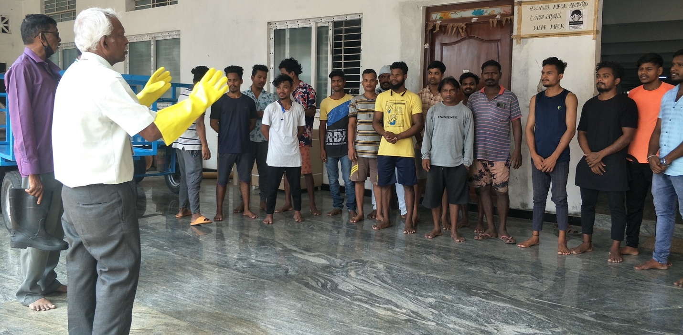
At Shanthi Compacting

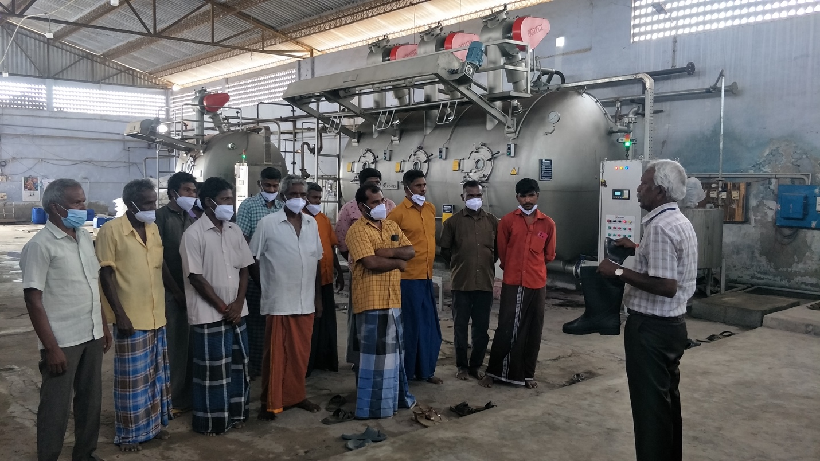
At Good Will Dyeing

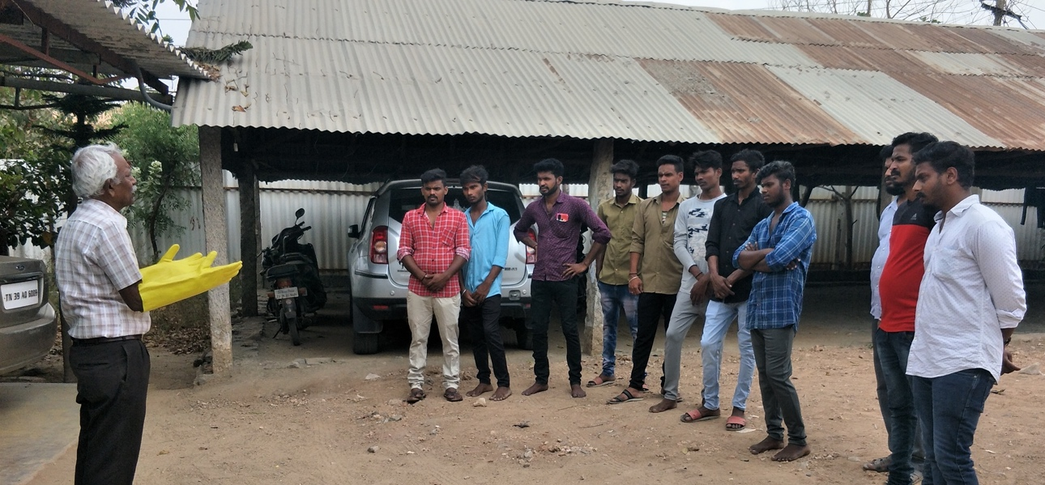
At Arun Printers

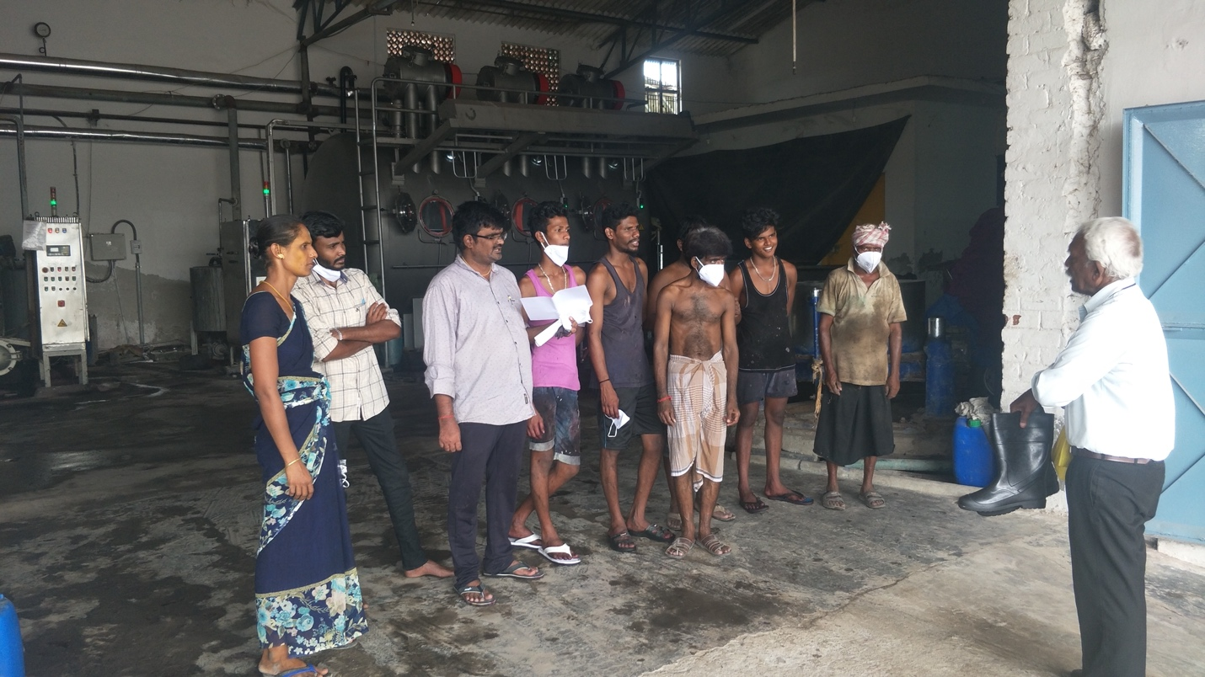
At SKN Colour Printers
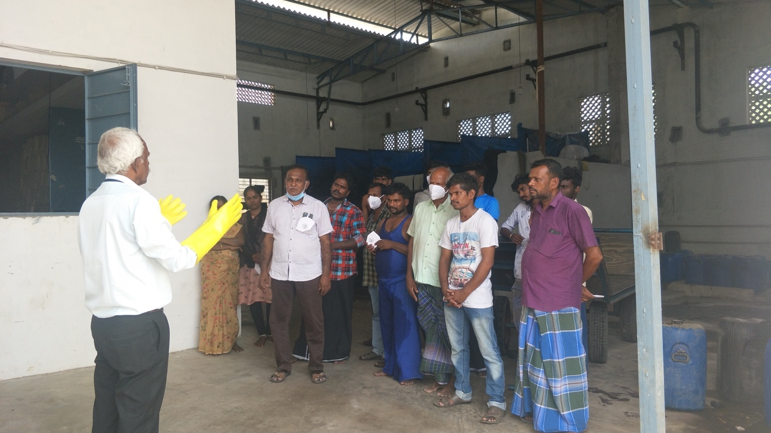
At Winman Process
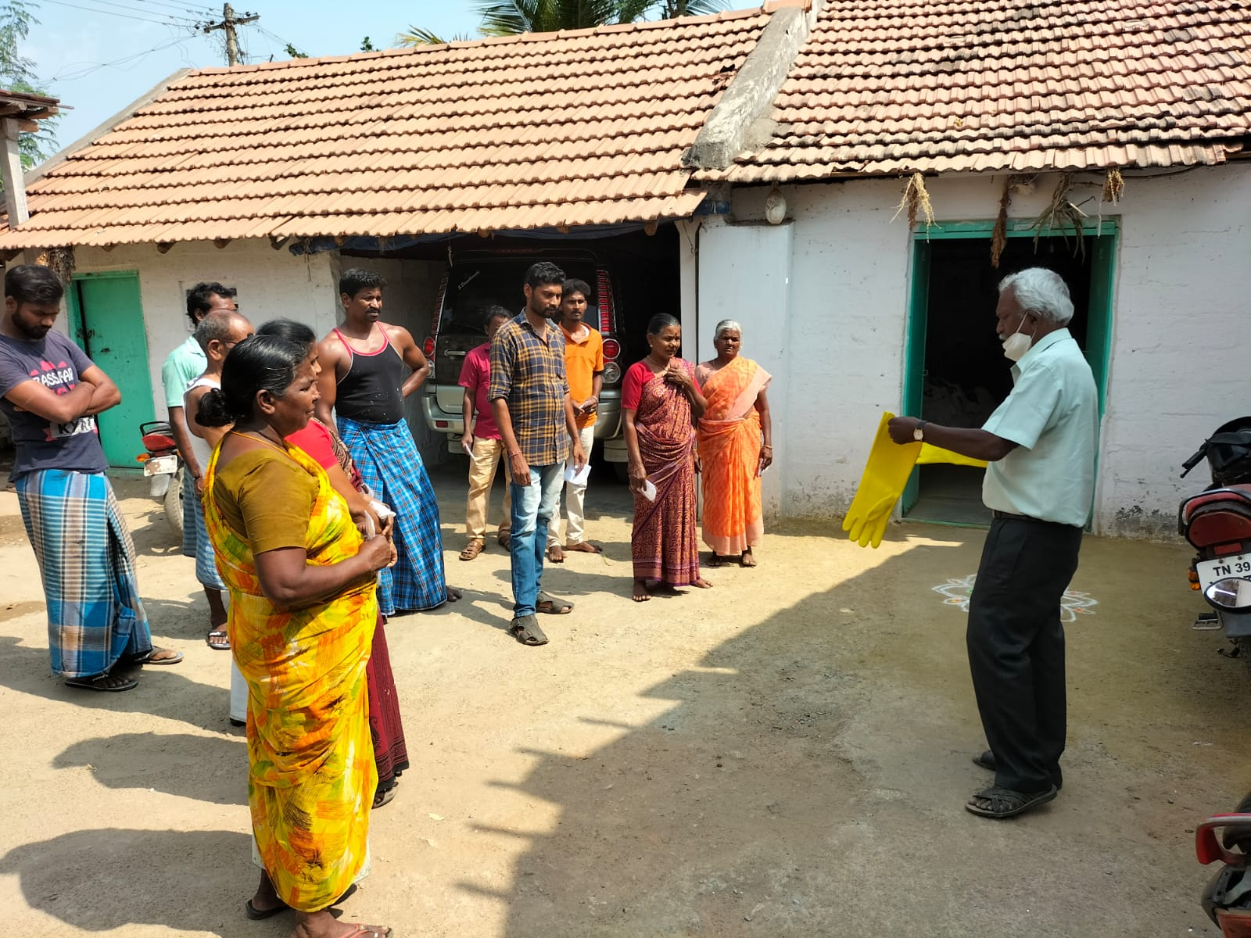

At Ramar Processing

The below photos are at Global Attire
