A Report on the Training Session on OHS for Women workers in the Leather Sector
Submitted to DWOI

Cividep India in collaboration with its partner CHANGE, organized a one-day training programme on occupational health and safety for women workers in the leather sector. The programme was funded by Development World Outreach Initiative (DWOI). The main objectives of the training programme were:
- To increase the awareness and capacity of women workers working in the shoe factories
- To gain understanding of the working condition and challenges of female workers with respect to the occupational health and safety in their workplaces
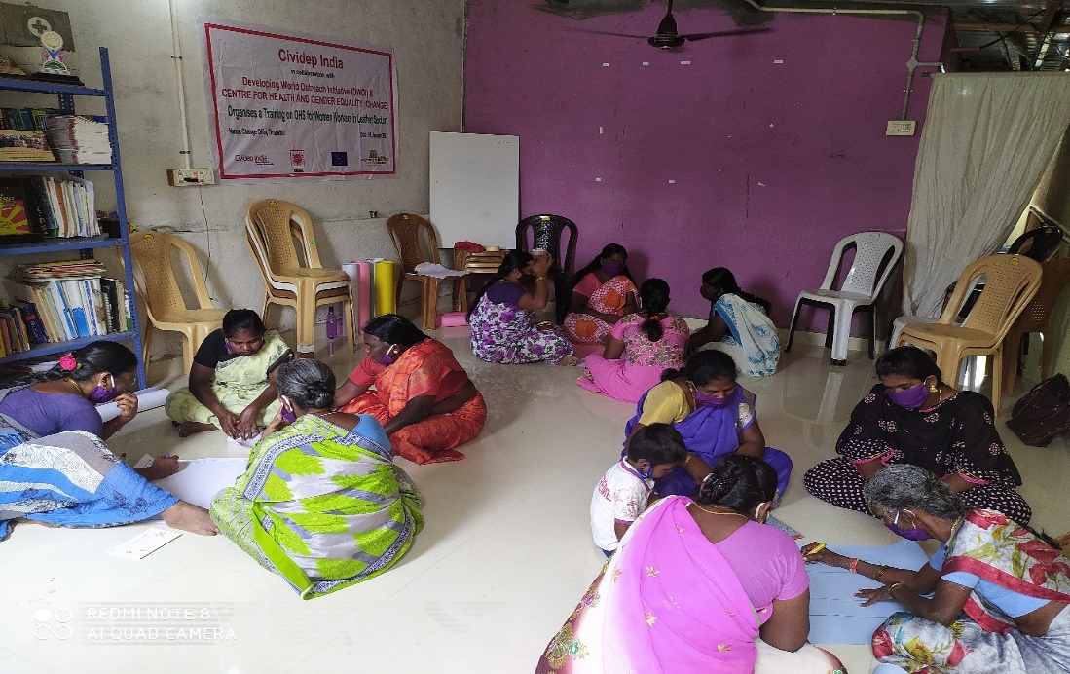
The programme was held on 31 January 2021. 21 female workers from villages in and around Tirupattur town participated in the training session. The participants were working in the assembly line of 14 shoe factories near Tirupattur. 12 of the workers were working on a permanent basis and the rest were contract or temporary workers. The COVID-19 pademic situation posed certain challenges in organizing the training programme. To avoid risks, only limited number of workers were invited for the training. All basic COVID-19 precautions were taken during the training.
Picture 1: Participants in Group Discussions

The training session started with the registration of participants followed by the welcome address of Mrs. Saraswathi, Secretary, CHANGE. Followed by the welcome address, Mr. Palanivelsamy, Director of CHANGE, gave the inaugural speech. In his speech Mr. Palanivelswamy requested the participants to make of the opportunity to build their knowledge and awareness on key issues pertaining to their working conditions. He mentioned that health of women, especially working women, have not been given adequate attention. He stressed on the need for the workers to have adequate knowledge their rights, entitlements and importantly, the risks and hazards that they have in their workplaces. He also thanked Cividep India and DWOI for their continuous support to organise trainings and other educational activities for workers, especially the vulnerable women workers.
Occupational Health and Safety Issues – Inputs of the Facilitator
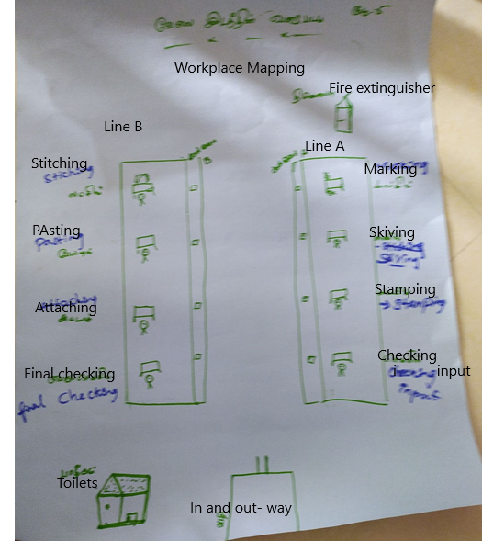
Kohila, Programme Coordinator, Cividep India facilitated the session. She gave a detailed overview of several occupational risks that female workers faced in India and described its impact on the health of the workers. She quoted from an ILO report that occupational diseases and accidents at workplaces alone claim around 2 million lives every year across the globe. She said majority of these deaths could be prevented if the managements followed safety standards and ensured the use of protective equipment.
Despite having strong laws such as the Factories Act to regulate working conditions including occupational health and safety, the situation in the factories are abysmal mainly due to the lax implementation of the laws. As a result, the workers are denied access to even the basic safety provisions in their workplaces. For example, the Factories Act mandates the factories to provide personal protective equipment (PPE) for workers who are employed in hazardous activities. But quite often, we notice that workers are forced to work without elementary safety equipment such as gloves, helmet, safety shoes etc. Workers in the shoe factories use chemicals such as solvents, glue and dyes which are dangerous for workers’ health. In the tanneries, we have observed that the workers handle harmful chemicals such as chromium without adequate protection. There are no inspections happening in these places to ensure that the basic safety standards are followed.
There were several accidents that occurred in the last few years which have taken place in the tanneries and shoe factories in and around Ambur. All of these accidents took place because of the callous attitude of the employers towards the health and safety of workers. In many cases the victims of these accidents were not adequately compensated and they were forced to spend their own money for treatments. The majority of the workforce in our region, especially the contract and temporary workers are not covered by the social security schemes such as the Employee State Insurance (ESI) or Employee Provident Fund (EPF). It was evident during the COVID-19 pandemic when many suffered without basic medical care or monetary support to manage income loss during the lockdown. Many companies that employ women in large numbers deny them maternity benefits. They create conditions so that the pregnant women or new mothers resign their jobs on their own.
In order to address these issues the workers should become aware of their rights. They should have the basic knowledge about the health risks and occupational hazards that they could face in their workplaces. They should also be aware of the legal mechanisms and the various avenues to seek remedies. She said one of the main objectives of this training is to equip workers with some knowledge of the hazards they have in their workplaces and to explore the ways to overcome them.

Group Discussions:
The participants were divided into five groups with four workers in each group. Each of the groups were given the following topics for discussion. Later, each group presented their discussion points to the participants.
- Body mapping
- General Working conditions
- Safety and other facilities available at the workplace
- Accidents and harassments
- Workplace mapping
Group 1: Body Mapping:
In the body mapping exercise, the group members discussed and mapped the numerous health issues faced by them in their workplaces including physical and mental health problems.
The workers in the leather sector encounter the following health problems:
- Head-ache
- Watery eye/eye irritation
- Breathing difficulty
- Shoulder pain
- Back pain
- Pain in the hip
- Skin allergies/rashes/itching
- Irregular periods and white discharge
- Stomach pain
- Skin in the fingers peel and fingerprints fade due to overuse
- Knee pain
- Leg pain
- Swollen legs

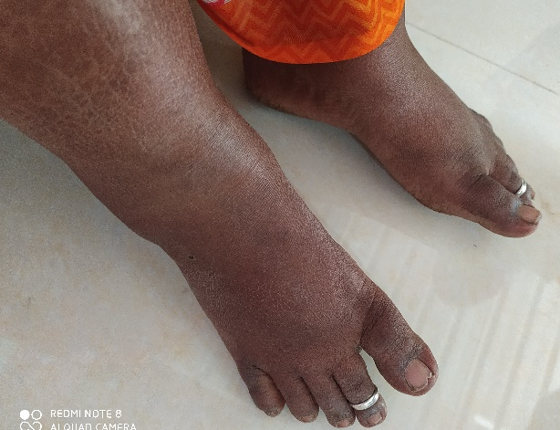
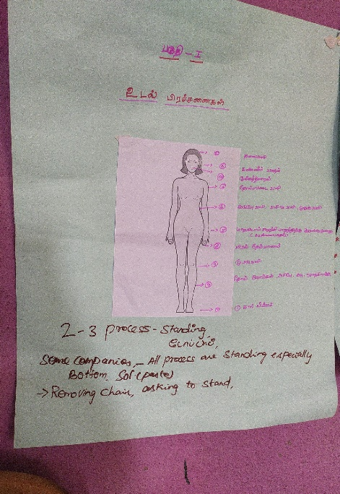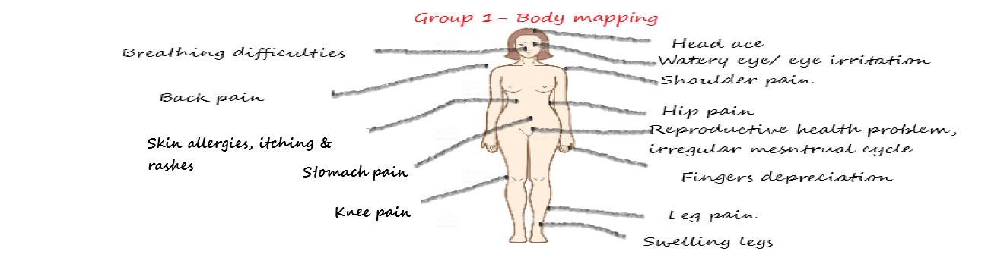
Picture 4: A Factory Worker with Swollen Legs
Picture 2&3: Body Mapping Exercise by the Participants

The workers informed that they also face mental health issues due to high work pressure and production targets. They often feel depressed due to verbal abuses by their supervisors. The workers always work with fear and anxiety which sometimes cause severe headache. The participants mentioned that the work environment does not allow them to have a relaxed or a peaceful state of mind.
The workers mentioned that they are given very short breaks and during the peak production periods they are denied breaks completely. This would mean that these workers cannot use washrooms when they require and would be given very short time to finish their lunch. According to the workers, this often results in severe reproductive health issues such as irregular menstrual cycle, white discharge, and stomach pain.
The use of chemicals such as solvents and glues, which are used in the pasting work, and the dyes that are there on the leather articles by default, cause health issues such as breathing difficulties, itching and skin allergies. The female workers in assembly lines work mostly in standing postures. They hardly able to sit. Some workers who do stitching will have to be seated all the time. The long hours of sitting or standing cause pain in the back, knees and lead to swelling on legs. The workers rued that although they face these many health issues, they do not have proper health facilities in the factory or outside to avail treatment.

General working conditions:
According to the participants, the majority of workers working in the assembly lines in shoe factories are women. The male workers are engaged only for technical jobs or at the supervisory level. The women work in these companies work on regular shifts from 9 am to 6 pm which includes the two tea breaks of 15-minutes duration and a lunch break of 30 minutes. However, in practice they are not given any tea break during the working hours and are given only 15 minutes for having lunch. If the workers do not adhere to it, they are shouted at by their supervisors.
From 9 am to 1.00 pm workers would face the maximum work load and they would not be able to leave their work spot even to use the toilets. In the evening, workers could leave the workplace only after 6.30 pm and that too only if their supervisors permit. If the workers prepare to leave home after their shift time, they would be asked rude questions. The shop floor workers are not paid for the extra hours of work they do at the factory. If the workers demand OT wages, they would be told that they do overtime as they failed to finish their target for the day. Same is the reason cited, when workers are made to work on their weekly holidays (Sundays) without overtime wages.
According to the presentations made by the workers, the companies lacked basic facilities such as potable drinking water, canteen, and clean toilets. Arrangements were made for clean drinking water only during the factory audits. The workers also said the water supply inside the factory premises. In the absence of a canteen, the workers are forced to have food under trees or other vacant places. The workers’ movements inside the factory is closely monitored and if the supervisor comes to know that a worker uses the washroom frequently, she would be shouted at.
The workers are not entitled to any sort of paid leaves in the shoe manufacturing companies in Tirupattur. And if a worker takes leave for one day, the wage gets deducted for two days. The company also withhold the wages of workers if they report ten minutes late for work.
Many factories do not have enough provisions for ventilation and light. A new unit of a factory which started operations recently in Tirupattur still does not have power connection. The machines are being operated by generators. So they are not switching on the fans or lights so as to cut down the consumption of the power from the generators.

Safety and other facilities available at the workplace:
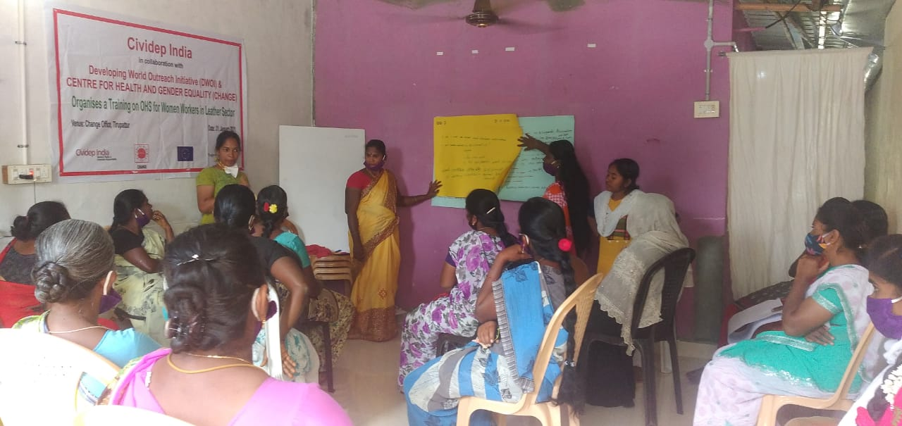
According to the presentations made by the workers, PPE such as gloves, head cover, goggles are not provided to all the workers. The management force them to use the PPE only when the factory audits take place. The first aid boxes on the shop floors are not fully stocked and contains only some basic medicines, cotton, pain balm and tincher ointment. Workers often refused medicines, if they report of minor illness such as headache.
The participants also reported that female workers often faint at work due to stress and other health problems. The fainted workers would be given a short break and would be asked to resume work as soon as they recover. In case the workers are given treatment at the cost of the company, it would be deducted from the workers’ salaries.
Picture 5: Participants making Presentations of their Group Discussion
Although the factories followed the basic COVID-19 precautionary measures, it has resulted in increased work hours for the workers. The workers were made to work extra to compensate for the loss of time that occur due to the precautionary steps such as screening of temperature, hand washing etc.
The participants reported that the leather companies in the Tirupattur region do not adhere to the rules of the Maternity Benefits Act which mandates maternity leave and child care support for working women. In contrast to the act, pregnant women are asked to work at the same pace as others and no special rest times are provided to them during the working hours. Unable to cope up with the pressure, the pregnant women quit their jobs. Workers said that no company in their region provide the legally mandated maternity leave of six months to working women. These factories do not have crèche facilities although the majority of workers were women. The participants said that all these factors make it difficult for women workers to continue their jobs after child birth.

Hazard Mapping:
The participants described in their presentations how their workplace looked like. The footwear manufacturing units have the conveyor system and operations such as marking, skiving, stamping, checking, stitching, pasting, attaching and final checking take place on the conveyor. The coveyor system was introduced in the region a few years ago and it fastened the production process. The result is that the workers get hardly any rest time. They have to work as fast as the conveyor belts move. If one worker delays, it will affect the whole system. So the workers would be subjected to verbal abuse and would be forced to forego their breaks to finish the targets.
Picture 6: Workplace Mapping by the Participants

According to the presentation made by the participants, the workers in the shoe factories the following accidents/hazards are common in their workplaces. They said that minor injuries happen every day, and major accidents would occur at least in a month or two.
S.No | Minor Accidents | Major Accidents
1. | Needle-stick injuries | Fingers getting cut in the machine
2. | Electric shocks | Hair stuck in the machine
3. | Sarees/clothes get stuck in the machine | burns on hand/skin
4. | Falling in the toilet due to slippery floor and poor maintenance

If an accident take place in the factory, the victims are taken only to the nearby government hospital. The victims are not taken to the private hospitals as the management is not ready to bear the cost for the treatment. A participant informed that while doing the work, her colleague’s hand got stuck in a machine. Her skin was completely burnt and her hand nerves were also affected. Due to the accident, she could not work for almost three months. The company paid only forher initial treatment. She had to pay for her follow up treatment. The company did not pay any compensation.
According to the workers, the female workers in the factories are also subjected to verbal abuse by their supervisors. Sometimes they also throw the articles (shoes) at the workers. This takes a huge toll on the mental health of the workers. The participants also mentioned that none of the companies have a functioning anti-sexual harassment committees. The committees are there only on papers, just to ensure compliance (during audits). They say that they do not feel safe to report any grienvances regarding the harassments they are subjected to.

Conclusion:
At the end of the training Kohila briefly explained the participants of the entitlements under the Factories Act and the Maternity Benefits Act. As per the Factories Act, the workers should not work more than 48 hours per week and for any extra work beyond that, they should be paid overtime wages. It is also mandatory for the companies to provide six months of maternity leave and companies which has more than 50 workers should have a crèche facility at the workplace. She urged the workers to demand their employers to provide them with PPE. She requested the participants create awareness among their fellow workers about the need for using the PPE provided by the company. She also advised the workers to feel free to make joint representations to their employers if they notice any potential hazards in their workplaces.
She further explained that the absence of trade unions in the industry is also a major reason for the extremely poor working condition and occurrence of harassments at the workplace. She requested the workers to join together and collectively raise their voice against the issues.
Kohila also asked the participants to be cautious about their deductions (of their contributions) with respect to social security funds (ESI/EPF). The asked the workers to get in touch with Cividep’s Workers Resource Center for any help regarding verifications and filing claims under EPF or the manual workers’ welfare board.

******

