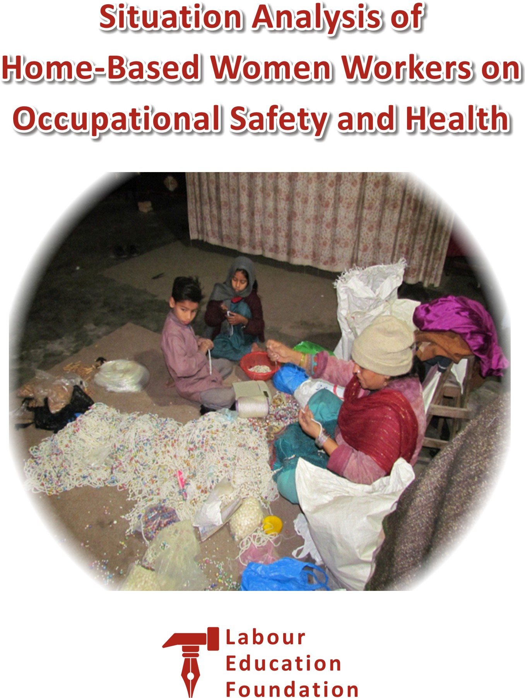
Research Report:
Situation Analysis of Home-Based Women Workers
on Occupational Safety and Health

Principal Investigator & Writer:
Dr. Huma Tabassum

Research Coordinator:
Jalvat Shehzadi
Labour Education Foundation


Labour Education Foundation
56-D, Adan Garden,
Harbanspura, Lahore
Tel: 042-37392496
www.lef.org.pk
Contents

Introduction 3

Home-based Workers 3

Literature Review 6

Home-Based Women Workers OSH Research in Pakistan 6

Legal, Social and Training Frameworks Supporting Home-based Women Workers 7

Legal framework 7

Social Protection Policies 8

ILO Training Approaches to Improve Working Conditions 8

Health Promotion Intervention Studies 8

Health and Disability/Injury Insurance and Occupational Health Services 9

Social security and medical care 9

SH Service for Informal Workers 9

Non-regulatory Efforts to Improve OSH in the Informal Sector 10

Conceptual framework of the study 10

Methodology 11

Focus Group Discussion 13

In-Depth Interview 14

Results Analysis and Discussion 16

Limitations of the study 34
Conclusion 34
Recommendations 34
Contributions 35
Acknowledgments 35
Funding 35
References 36

Annex – A 38
Questionnaire for Quantitative study on
OSH Condition of home-based women workers in English
Annex- B 43
Questionnaire for Quantitative study on
OSH Condition of home-based women workers in Urdu

LABOUR EDUCATION FOUNDATION (LEF)

Introduction
Globalization and widespread economic restructuring in recent decades have facilitated an increase in the informal employment sector¹. Small-scale industries have been estimated to employ 45.95% of the workforce in developing countries². The cottage industry (Home-based work) is a subgroup of informal small-scale industries³ portrayed by craftsmen, frequently sorted out around families and done in homes.
The term informal sector was first used in the International Labour Organization (ILO) 1972 report on Kenya and referred to workers who were not recorded, protected, and regulated by public authorities^{.4} Three specific attributes stood out: (i) poverty caused by employment that did not enable workers to earn enough to feed their family, gain access to decent health care and education, or acquire safe housing; (ii) survival needs that forced these workers to seek and accept low-productivity income-earning opportunities; and (iii) a globalized division of labor where enterprises introduced more flexible and decentralized production systems to cut costs.5 Workers and entrepreneurs have been termed informal because of one important characteristic: They are not recognized or protected under national governments' legal and regulatory frameworks.6 When little or no legal or social protection is granted, workers cannot enforce contracts or own property. There is little workplace safety, benefits are lacking, the working time is long, and possibilities for skills development are scarce.⁶

Home-based Workers
Home based workers form a significant informal employment workforce. It used to be argued whether a "home based worker" really was a worker or a self-employed, independent entrepreneur who was "home-based." The ILO's Home Work Convention, adopted in 1996, provided more clarity to the debate and helped distinguish these two concepts. It defines homework as follows:
A person carries the term homework out, to be referred to as a home based worker (i) in their home or other premises of his or her choice, other than the workplace of the employer, (ii) for remuneration; (iii) which results in a product or service as specified by the employer, irrespective of who provides the equipment, materials or other inputs used, unless this person has the degree of autonomy and of economic independence necessary to be considered an independent worker under national laws, regulations, or court decisions.⁷
The Convention excludes workers who do not have a subordinate relationship with employers and establish their direct relationship with the consumer of the end product. Dependence on an employer, an absence of control over production methods, and work for wages are differences between home based workers and the self-employed who use their homes as a workplace.8&24
Prügl and Tinker (1997) 9 described four home-based work categories: (i) industrial homework or outwork common in the labor-intensive processes of industries such as footwear, electronics, garment production, and cigarette rolling, (ii) crafts production including basket-weaving, pottery makers, and ornaments makers, (iii) people who make and sell food on the street or in small stores, and (iv) white-collar homeworkers including data-entry clerks, translators, computer programmers, typists, and telemarketers. Women in Informal Employment: Globalizing and organizing also include the personal services category with laundry service, beautician, and barber.10. During periods of slow production, home based workers may work for several employers. Although much necessary mundane work occurs at home, household work, and childcare, "bringing work home from the office" does not constitute homework.11
In many countries, home-based craftwork is a substantial piece of the economy³ and is an essential source of employment worldwide. The vast majority of the labor force in South Asia is in agriculture and the informal sector, who do not have any protection to repay them if there should be an occurrence of work-related ailments and wounds and whose employments are non-adaptable, shaky, and uncertain, but at the same time are risky, undesirable and dangerous^{12, 13, 14}.
While informal employment is universally characterized by lack of social protection, exposure to occupational health and income risks for subpopulations of informal workers is determined by the specific physical and social environments of their workplaces. Efforts to improve the health of informal workers should consider the contexts in which informal work takes place to develop tailored interventions for subpopulations of informal workers¹⁵.
Pakistan is undergoing a transition from an agriculture-based economy to one based on service/manufacturing sectors. Pakistan has both large- and small-scale industries. Together they represent about 24% of Gross Domestic Product (GDP), while the small-scale industries generate only 5% of GDP. Cotton material generation and clothing production are Pakistan's biggest enterprises; representing about 66% of the product trades and 40% utilized work power.
Large scale industries are registered under the Factories Act 1934, while small scale industries are not registered under this Act. The home-based sector is a part of the informal sector and is essential for generating not only employment but help in earning foreign exchange for the country.
In Pakistan, there are 20 million home-based workers (HBW), and out of it, the 12 million are women, who are more deprived and vulnerable. Home-Based Women Workers (HBWWs) mostly live in the suburban slum area of cities living below the national poverty line. They work within their homes and are contracted by individual entrepreneurs or firms, often through an intermediary. They are given the raw materials and paid per piece but cover many costs of production; workplace, utilities, and transport. They typically do not sell the finished goods themselves and do not know where or for whom the goods will be sold.
There is no legal protection for them; therefore, they are totally out from government labor, social security, and occupational safety & health mechanism. The situation of women workers is worse as they get lower average wages than their male counterparts. Their work has different health hazards, but they are not aware of them; therefore, occupational safety and health are alarming. The primary health problems, including tuberculosis, kidney problems, eyesight; however, no formal data is available, as the home is their workplace; therefore, health issues do not confine to their own but affect their children and family.
These workers often suffer from numerous occupational diseases. The biggest downside is the informal nature of their job, due to which these workers cannot get adequate health care, safety, and other fringe benefits from the government. Additionally, their work-related health issues are usually overlooked by the relevant health authorities. Therefore, there is a dire need to identify the most common diseases faced by such workers ¹⁸.
There is no detailed study available in home-based women workers' occupational safety and health situation. This research will be the first document that will give details on the health and safety situation of home-based women workers.
The study's main objective is to know the existing Occupational Safety and Health situation of HBWWs.
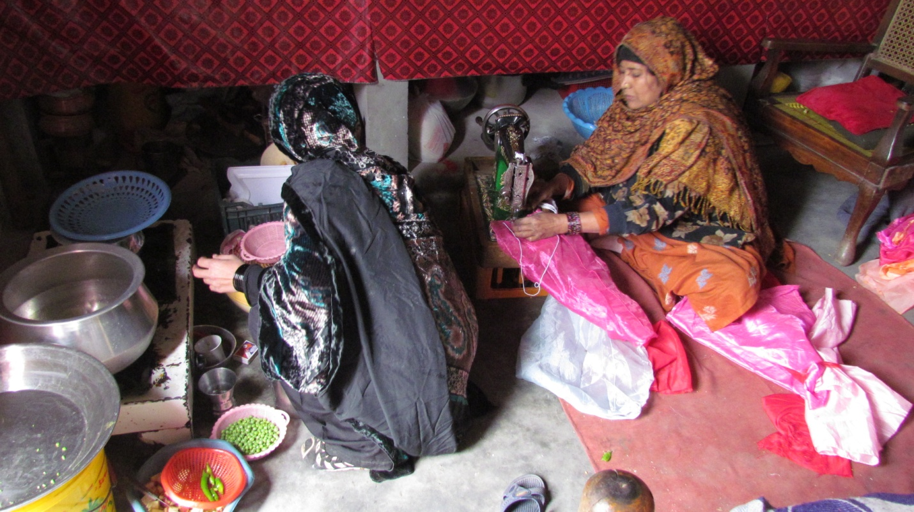
A HBWW is busy in her stitching job and in the close vicinity food is being cooked.

Literature Review
To gain an understanding of the topic, desk review of the literature was done to realize the current situation concerning research studies undertaken, review of related laws, regulations, or OSH guidelines and existing gaps. The result of current literature present from Pakistan perspective is as follows:

Home-Based Women Workers OSH Research in Pakistan
Home-based Women workers are informal workers who carry out remunerative work at home or in adjacent premises, rather than at employers' premises. They are usually engaged in manufacturing and post-manufacturing tasks such as embroidery/stitching, carpet weaving, paper products, handicrafts, football making, etc. These workers are often confronted with unhealthy living and working conditions. Thus, the home-cum-workplace environment puts them at higher risk of suffering from occupational diseases. Falling sick results in below-par performance, low-quality output, and significant delays in product delivery. Eventually, a dreadful impact is witnessed on the earnings of these workers, which further reduces their ability to seek appropriate medical treatment¹⁸.
As per UN-Women report ¹⁹, home-based workers contributed almost 400 billion PKR (nearly 3.8% of the total GDP) through their wages to the economy of Pakistan in 2013–2014. However, they are excluded from the mainstream market economy, health protection, occupational safety, and social insurance. In Punjab, 44.29% of the population is engaged with an informal economy in which female and male labor force participation rates are 6.77% and 37.52%, respectively. The majority of the female labor force is home-based workers ^{20.}
According to the Punjab Home-based Workers Survey (2016)²¹, they face the following challenges while working:
1. Poor lighting situation at the workplace.
2. Lack of ventilation and protective equipment.
3. Workplaces are congested, hot and suffocated.
4. Workplaces contain dust and fumes.
5. Subject to chemical hazards.
6. Working with sharp machines/tools.
7. Bad posture.
8. Long working hours.
These challenges pose massive health risks; thus, they are often confronted with numerous occupational diseases. A healthy worker generates household income and plays a pivotal role in enhancing productivity, leading to sustainable economic growth. Despite their undeniable importance, pertinent government organizations and health practitioners are ignorant of the occupational health issues of HBWWs. Undoubtedly; the ignorance is due to the disguised and isolated way of these workers¹⁸.

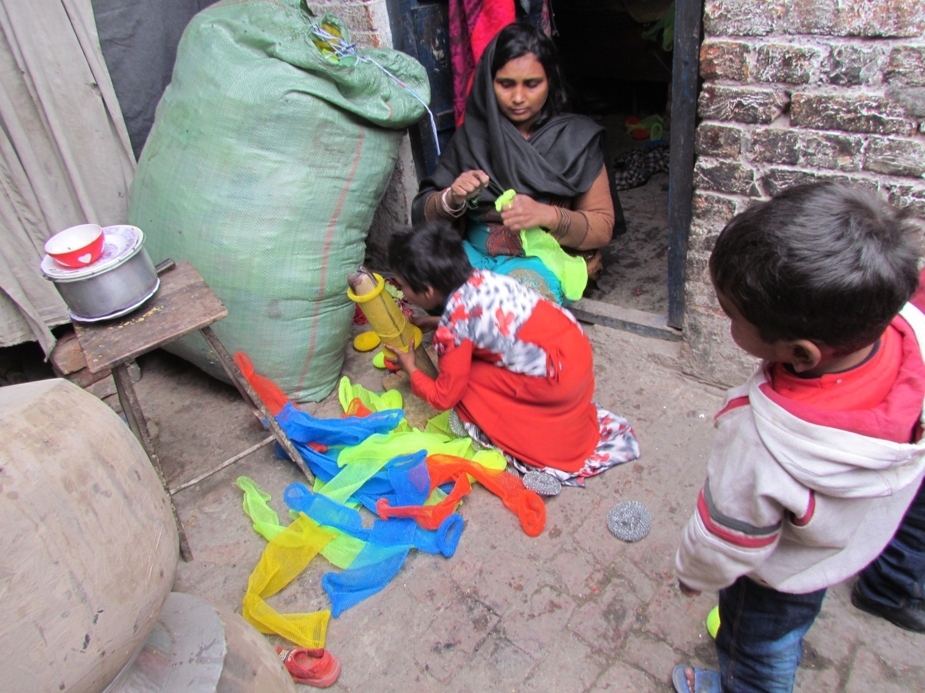
Kids are also part of HBWWs Jobs. A female is busy making utensils cleaning net plastic scourers and her little girl is helping her in her job.

Legal, Social and Training Frameworks Supporting Home-based Women Workers

Legal framework
Informal workers in Pakistan lack employee status. They work at home and maybe self-employed or temporary workers. Most Pakistani Labor laws apply only to formal workers and do not protect informal workers in the domestic, homework and agricultural sectors. Informal home-based women workers lack employment contracts and awareness of their legal rights. Pakistani social security laws fail to provide informal workers with the treatment of work-related accidents, diseases, injuries; unemployment, retirement insurance and workers' compensation.
After a long and systematic campaign for these workers legal and social protection improvements, the efforts by Labour Education Foundation, Home Net Pakistan, and different other organizations working for home-based workers protection and betterment of this field "The home-based worker's act" was presented in the Parliament but it did not come into effect.

Social Protection Policies
No universal pension scheme is available.

ILO Training Approaches to Improve Working Conditions
Since the 1980s, the ILO has developed training programs and materials for small enterprises, informal sector operators, and even home-based workers. Perhaps, the most well-known is the participatory Work Improvements in Small Enterprises (WISE) approach—first published in 1988—and known as Higher Productivity and a Better Place to Work16. Moreover, such pieces of training were either not approachable to a large group of home-based workers or were done in isolation. There is no such documentation available in this regard.

Health Promotion Intervention Studies
No such studies have been done in this regard. The crux is that research studies to evaluate OSH exposure have not been conducted to provide valuable information to government policymakers. Health and safety training programs based on ILO methodologies have not been conducted with Pakistani informal home-based workers.
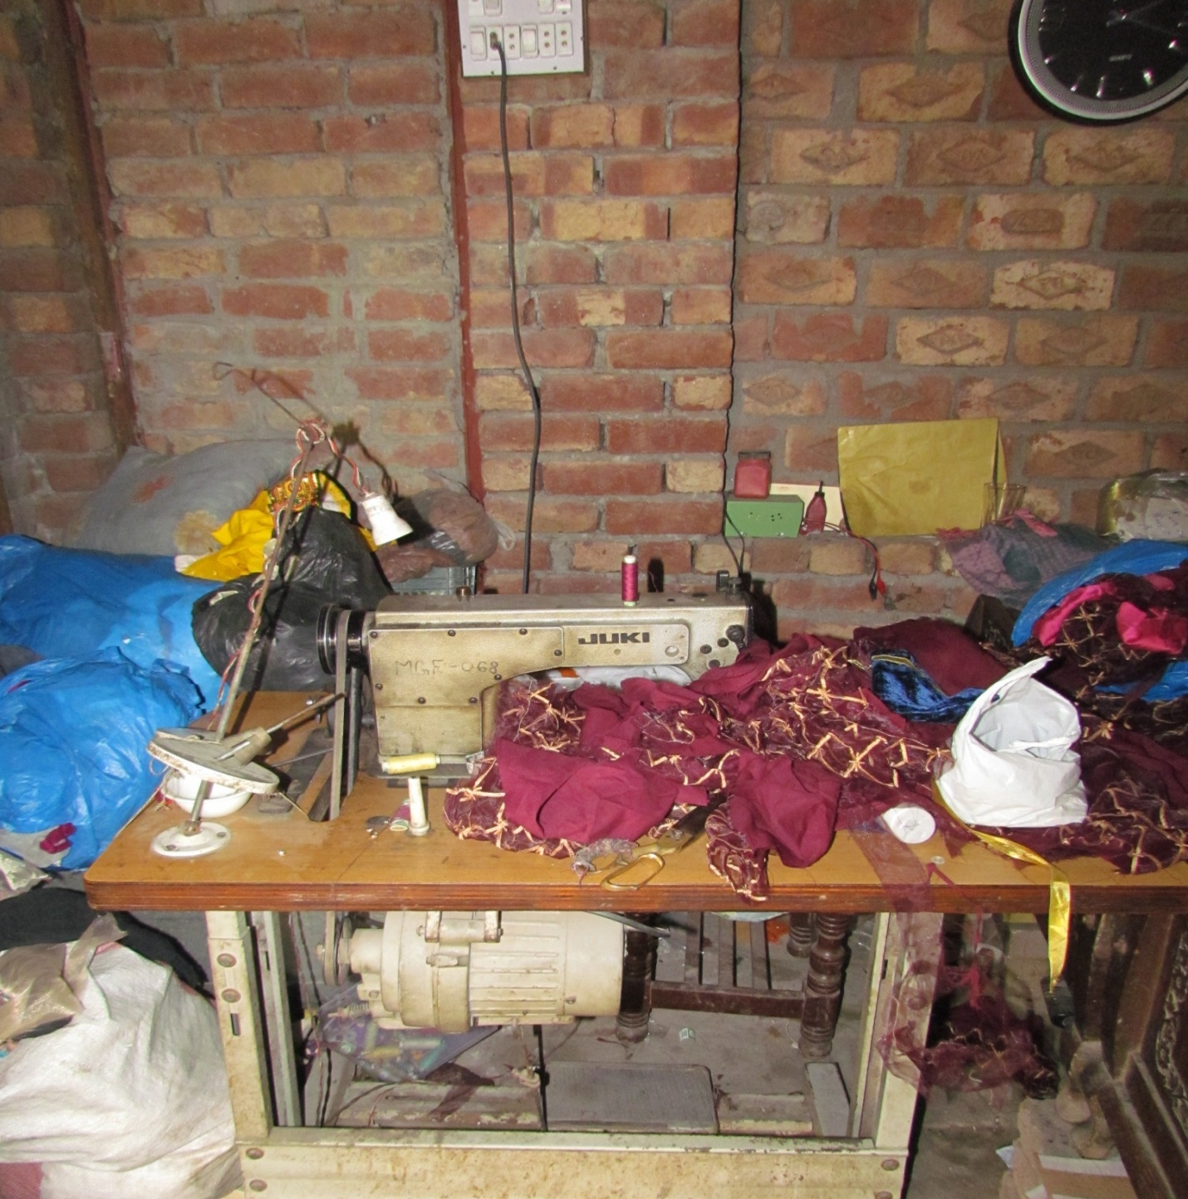
Above mentioned picture shows various work related hazards can be observed in this picture of HBWWs Work Station

Health and Disability/Injury Insurance and Occupational Health Services

Social security and medical care
There is no universal health care scheme. The government has started insaf health cards, but it is in the infantile stage. So no such provisions are available.

SH Service for Informal Workers
Such services are not available.

Non-regulatory Efforts to Improve OSH in the Informal Sector
Home Net Pakistan and Labour Education Foundation working for home-based workers protection have made many efforts, but enactment is still awaited.

Conceptual framework of the study:
Following conceptual framework Adapted from Litong et al. (2002) and World Health Organization (2010) was consulted for the questionnaire design of the study project.
Figure-1
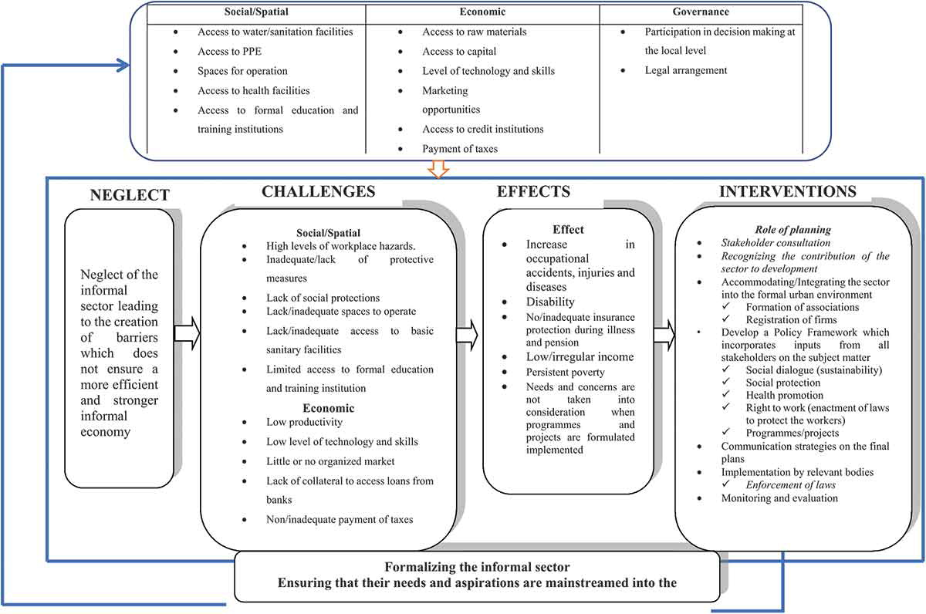

Methodology
The research design is the mixed method of both quantitative and qualitative. The cross-section descriptive study was undertaken with female home-based workers of three towns of Lahore suburban slum areas, i.e., Khaliq Nagar, Ahmed Town, and Nishter Colony, from April to June 2021. The purposive sampling technique was used for study participants. Government officers and OSH experts also belonged to Lahore District were included. A self-administered questionnaire was used for face-to-face data collection of the quantitative part of the study. The same was done for the qualitative part using an interview guide for in-depth interviews of the labor department and focus group discussion of the female home-based workers.
All-female home-based workers were contacted through social mobilizers of the LEF. A total number of home-based women workers was collected of these towns, and study participants were selected through the lottery method from the list. All who refused to participate in the study were excluded, and the next one from the lottery list was selected. All those who gave verbal consent and were above the age of thirteen were included in the study. Those who could not complete the information and refused the questionnaire were excluded from the study. The study participants belonged to three broad groups, i.e., stitching, zariadda work, and hand embroidery work. The stitching group was involved in the stitching of trousers, clipping, denim/jeans thread removing, and garment packing, zariadda workgroup was involved in zariadda work, tussle making and beadwork on females shawls or headscarves, Hand embroidery workers were engaged in hand embroidery and embroidery work on shoes and toys.

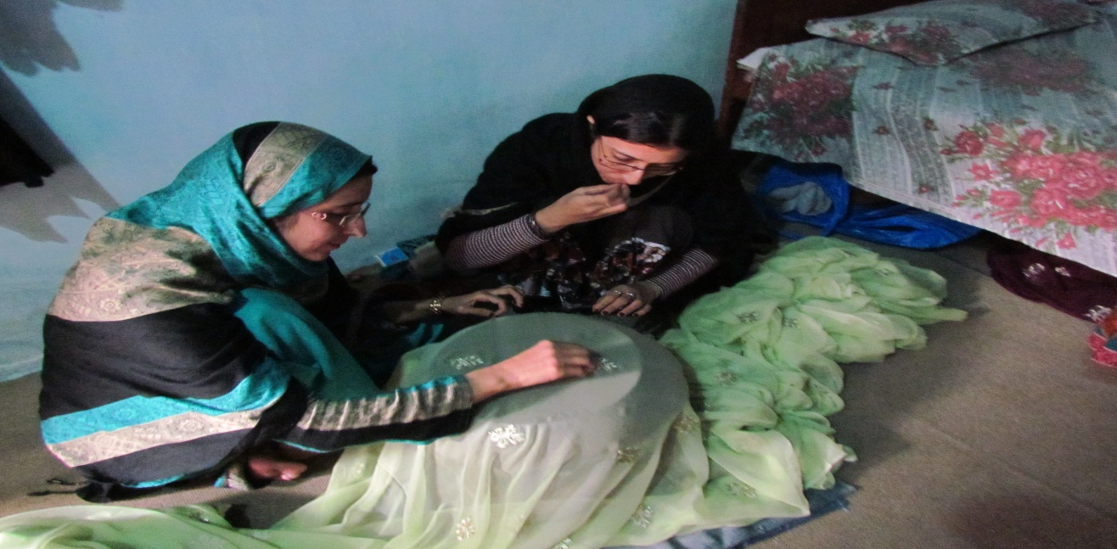

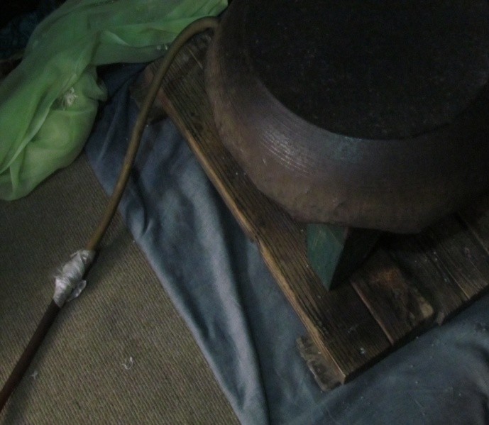
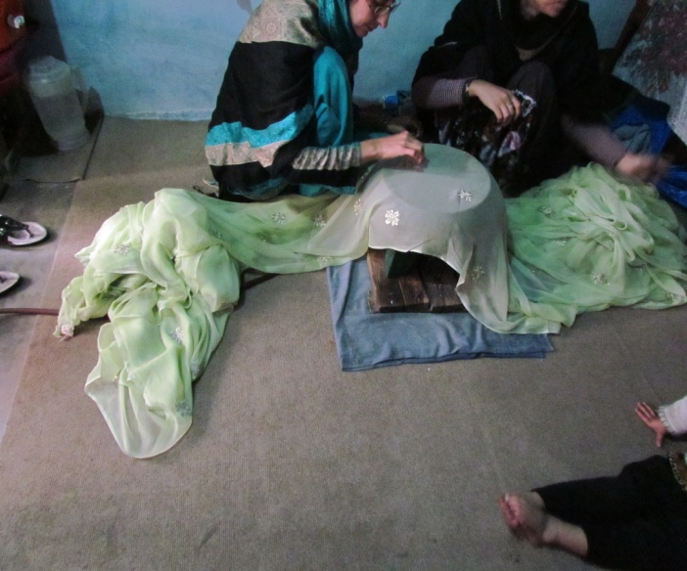
HBWWs are busy in pasting beads on a head scarf .The beads are pasted on scarf cloth when it is placed above a hot steel pan paced above the gas stove, which is used to warm the steel pan to help stick the beads on the scarf cloth; Fumes of incomplete combustion of gas leads to headache and eyes irritation of these workers
For quality control daily, the technical expert checked forms for completeness of the information, and those with incomplete data were removed from the study data.
The study questionnaire was designed in both Urdu and English by a technical expert who has experienced Occupational Health Expert. The quantitative descriptive cross-sectional study questionnaire has different sections of the socio-demographic profile, work conditions, health status related to work, number of injuries, wages, awareness of OSH laws, and OSH pertaining to their work. Pre-testing of the questionnaire was done with ten participants. Their comments and responses helped to further edit the items in the questionnaire. Pre-tested participants were not included in the study group.
Three local social mobilizers of LEF did data collection after training by the technical expert of the study. All the interviews were done in the privacy of the home and were done on one basis to avoid group recall bias if anyone from home is present or any other home-based workers are present and listening. The results were entered into an excel sheet and further analyzed through SPSS Version 22.
The technical expert of the study conducted the qualitative study part. For qualitative research, fourteen home-based women workers were selected for focus group discussion. At the end of the focus group discussion, they were also made aware of occupational health safety concerns of their work and how to manage these at their workplace. The responses coding was done, themes were identified, and results were gathered. Two officials of the Punjab Human Resource and Labour Welfare Department and one OSH expert were part of our in-depth interview part of the study. The questions of the focus group interview guide are as follows:
What are the major health issues in the community? What are major health issues due to their work? Does the HBW know about occupational safety and health? What is the wage rate, and what are their major expenditures? Does the HBW understand the minimum wage rate in Punjab? Does the HBW know about the government social protection schemes? Does the HBW community have information on labor laws? What are the primary institutions at the community level? The results are shared at the end of this chapter.
Three in-depth interviews of officials of the Punjab Labour Department were conducted. The main objective of these interviews was to know the government's response to HBWWs occupational health and safety situation. The questions in the interview guide are as under:
- Is the labor department having complete data of HBWWs in district Lahore?
- What are the significant interventions of the government to improve the HBWWs situation on health and safety?
- Does the government have any project to educate the HBWWs on occupational safety and health?
- What is the situation of labor inspection for HBWWs in district Lahore?
The coding and themes were not possible as all the responses to questions were in the form of "No, we do not do it due to the absence of a regulatory framework." Government OSH experts had not ever inspected any home-based work location and had never imparted training. His response was also negative based on this pre-text that home-based informal workplaces are not part of any inspection regulations.

Focus Group Discussion:
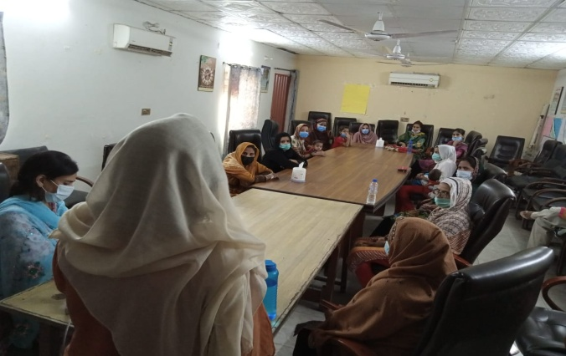  Focus Group Discussion with HBWWs  at office of LEF, Lahore | 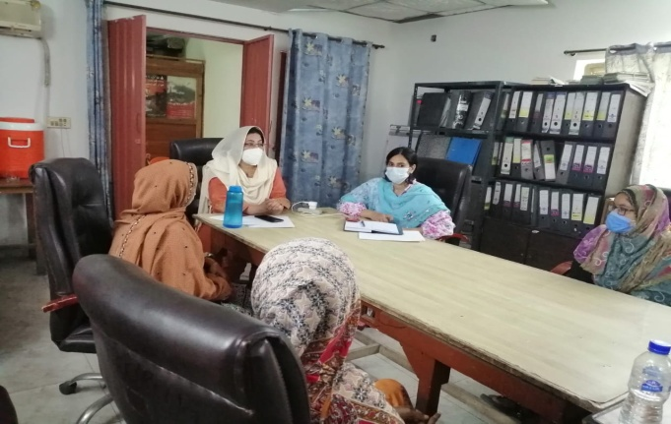  Notes taking is being done by  Ms. Jalvat Shahzadi and Dr. Huma Tabassum  is engaging HBWWs in focus group discussion at office of LEF, Lahore
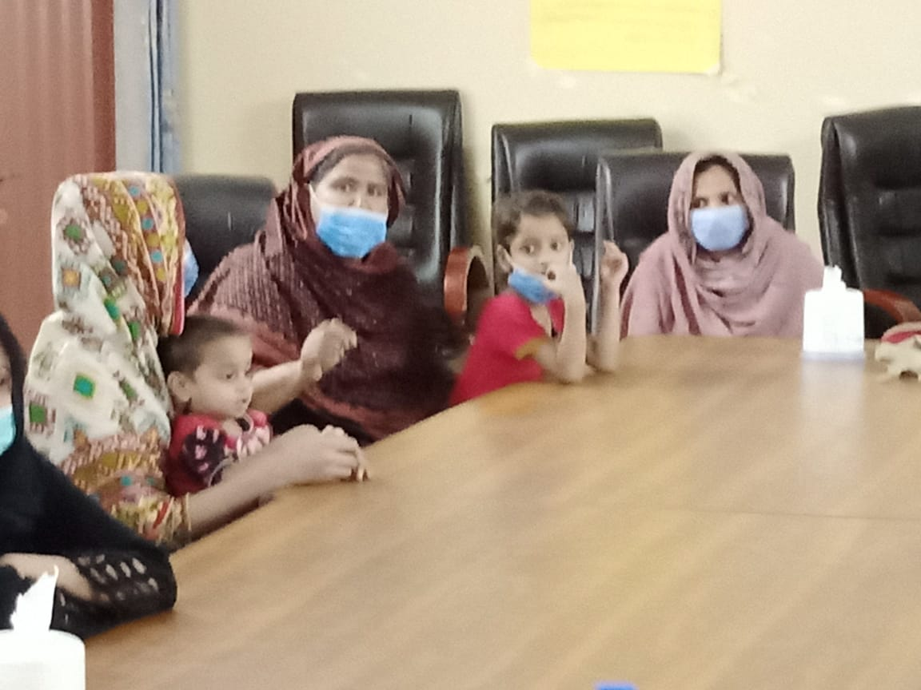 | 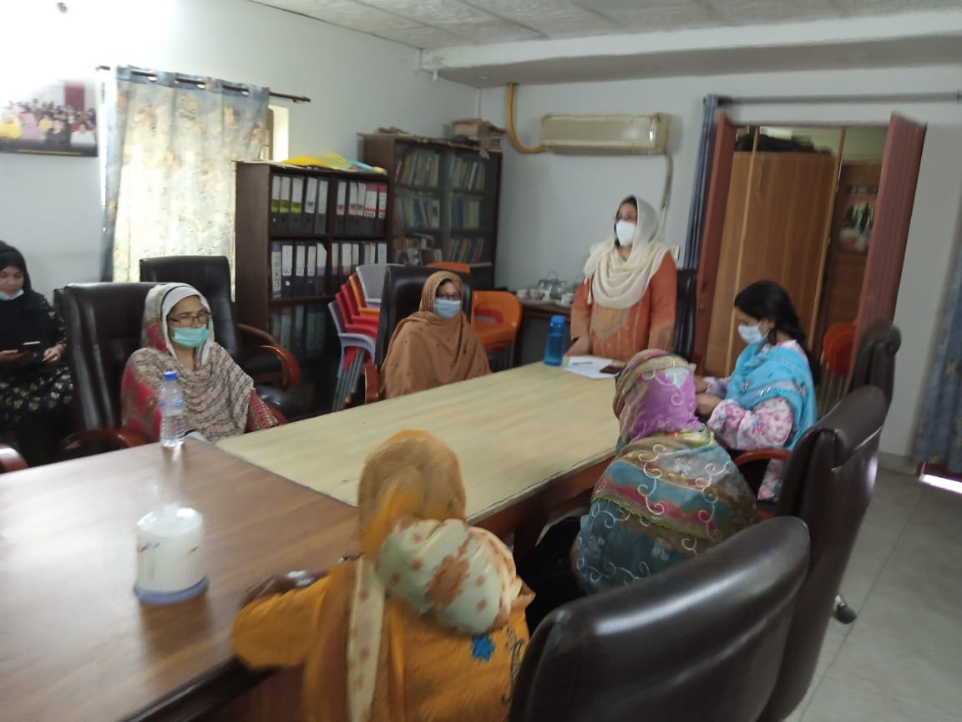

In-Depth Interview:
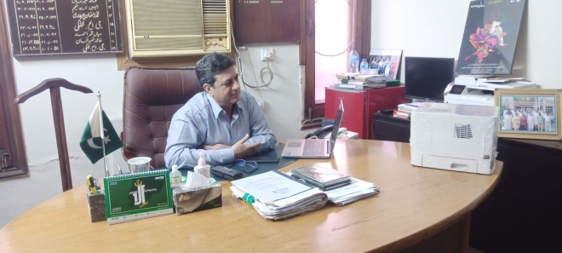  The in-depth interview session with  Director Labour Government of the  Punjab in his office at Directorate of  Labour Welfare –Lahore. | 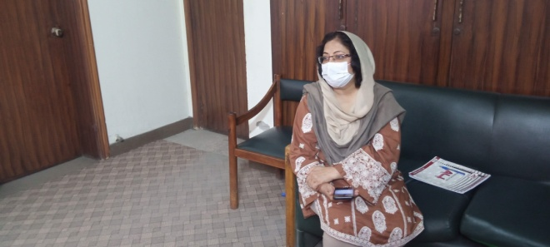  Principal Investigator Dr. Huma Tabassum having interview of Director Labour Government of the Punjab in his office-Lahore.
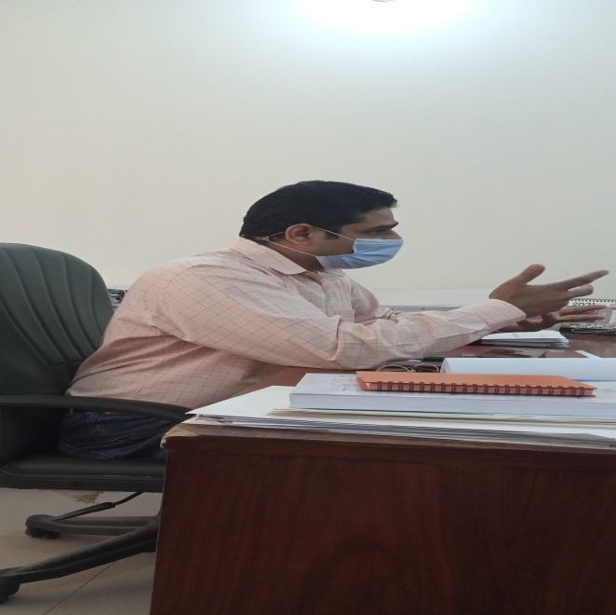  Compensation Commissioner – Lahore during in depth interview with Principal Investigator Dr. HumaTabassum. | 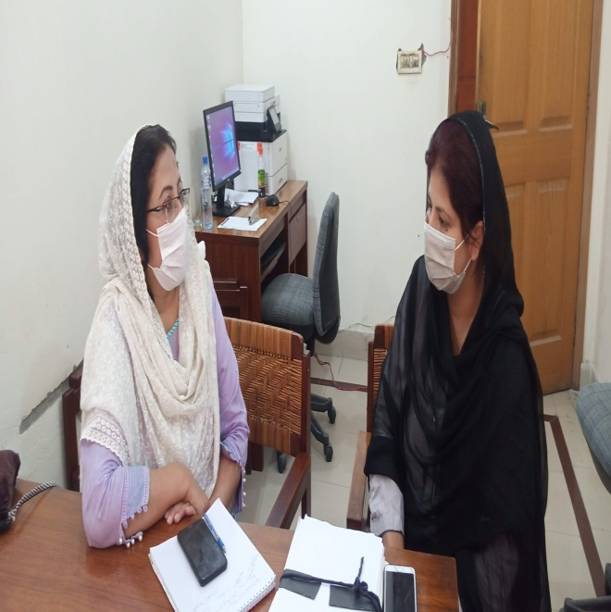  Principal Investigator Dr. Huma Tabassum having interview of OSH and Legal Expert at Directorate Labour and Human Resources.

Results Analysis and Discussion
There were 116 home-based workers interviewed during data collection. The primary age of 32.16±9 years, and the main working experience was 3.6±4.43 years. The median (IQR) number of dependent children was 2 (4), and for injury, the frequency was 3 (1), and loss during lockdown was 21155.17±11127.21 rupees.
Table 1: Frequency distribution of Home Based Workers according to Work Characteristics
Variable |  | Frequency | Percentage
Area of Work | Stitching | 41 | 35.3
Area of Work | Zariadda Work | 36 | 31.0
Area of Work | Hand Embroidery | 39 | 33.6
Work Place Size | 2 Marla | 96 | 82.8
Work Place Size | 3 Marla | 11 | 9.5
Work Place Size | 4 Marla | 05 | 4.3
Work Place Size | 5 Marla & Above | 04 | 3.4
Work Location | Own House | 111 | 95.7
Work Location | Rented | 05 | 4.3
Payment Basis | Piece Rate | 107 | 92.2
Payment Basis | Contract | 09 | 7.8
Total |  | 116 | 100
The table above showed that among the 116 home-based workers, 41 (35.3%) were doing stitching, 36 (31%) were doing zariadda work, and the remaining 39 (33.6%) were involved in hand embroidery. The workplace size mainly showed they had 2 Marla settings, i.e., 96 (82.8%), 11 (9.5%) had 3 Marla working place, 4 Marla was occupied by 5 (4.3%), and 5 Marla & above was occupied by 4 (3.4%). Work location was owned by 111 (95.7%) HBWs, and 05 (4.3%) had rented houses. Payment basis was according to base rate among 107 (92.2%) and on contract basis was 09 (7.8%). (Table 1)
Table 2: Frequency distribution of Socio-demographic Profile of Home Based Workers
Variable | Frequency | Percentage
Age (Years)
≤ 35 | 81 | 69.8
> 35 | 35 | 30.2
Marital Status
Single | 21 | 18.1
Married | 89 | 76.7
Others | 06 | 5.2
Education
Illiterate | 42 | 36.2
Primary | 30 | 25.9
Middle | 34 | 29.3
Matric & Above | 10 | 8.7
Income Per Piece
1 to 50 | 77 | 66.4
51 to 100 | 14 | 12.1
101-500 | 22 | 19.0
501-1000 | 03 | 2.6
Wage Received
Daily | 02 | 1.7
Weekly | 85 | 73.2
Monthly | 10 | 8.6
Fortnightly | 19 | 16.4
Total | 116 | 100
The above table showed that there were 69.8% (81) HBWs having age ≤ 35 years and the remaining 30.2% (35) had age > 35 years. The marital status of the HBWs showed that mostly 76.7% (89) were married, and 18.1% (21) were single. There were 36.2% (42) HBWs were illiterate, 25.9% (30) were having primary education, 34 (29.3%) had done middle, and the remaining 8.7% (10) had passed grade ten and above. There were 1 to 50 rupees taken per piece among 77 (66.4%) HBWs, 51 to 100 rupees were taken by 14 (12.1), 101-500 were taken by 19% (22) individuals, and only 3 (2.6%) took 501 to 1000 rupees. The wage received was weekly by 85 (73.2%), 02 (1.7%) took it daily, monthly wages were taken by 10 (8.6%), and 19 (16.4%) took fortnightly. (Table 2)
Table 3: Frequency distribution of Work Related Characteristics of Home Based Workers
Variable | Frequency | Percentage
Written Contract
Yes | 05 | 4.3
No | 111 | 95.7
Paid as per Agreement
Yes | 94 | 81.0
No | 22 | 19.0
Paid if get Hospitalized
Yes | 02 | 1.7
No | 114 | 98.3
Health Insurance
Yes | 04 | 3.4
No | 112 | 96.6
Total | 116 | 100
The above table showed that only 05 (4.3%) HBWWs had signed a written contract, and 81% (94) get payment as per their agreements. Regarding health issues, only 1.7% (02) get paid for their hospitalization. Only 4 (3.4%) had got themselves health insurance. (Table 3)
Table 4: Frequency distribution of Completing Work-Related Characteristics among Home Based Workers
Variable | Frequency | Percentage
Work on Weekends to Meet Target
Yes | 72 | 62.1
No | 44 | 37.9
Routine of Weekend Work to Meet Target (n=72)
Occasionally | 10 | 13.9
Mostly | 62 | 86.1
Daily Working Hours Excluding Break
Always 08 Hours | 43 | 37.1
Occasionally 08 Hours | 40 | 34.5
Every time >8 Hours | 33 | 28.4
Take Breaks During Work
Always | 26 | 22.4
Often | 59 | 50.9
Occasionally | 20 | 17.2
Seldom | 11 | 9.5
Duration of Additional Break (if any)
30 minutes | 61 | 52.6
< 30 minutes | 55 | 47.4
Total | 116 | 100
The above table showed that there were 72 (62.1%) workers who worked on weekends to meet their targets and routine of this weekend work within 72 workers showed that 62 (86.1%) did that mostly and only 10 (13.9%) did that according to workload. Regarding working hours, 43 (37.1%) always work for 08 hours, 40 (34.5%) occasionally work for 08 hours, and 33 (28.4%) work more than 08 hours every time. Break frequency during work showed that 22.4% (26) always take breaks, 59 (50.9%) take breaks often, 20 (17.2%) took occasionally, and the remaining 9.5% (11) seldom took breaks. The duration of additional breaks showed that 61 (52.6%) took extra work breaks of 30 minutes and 55 (47.4%) took less than 30 minutes breaks. (Table 4)
Table 5: Food Frequency among Home Based Workers
Variable |  |  |  | Frequency |  | Percentage
Daily Food Taken
Two times |  |  |  | 49 |  | 42.2
Three times |  |  |  | 67 |  | 57.8
Food items Taken
Meat, Pulses, Vegetables |  |  |  | 41 |  | 35.3
Pulses, Vegetables |  |  |  | 24 |  | 20.7
Meat, Pulses, Vegetables, Milk, Fruits |  |  |  | 19 |  | 16.4
Meat, Pulses, Vegetables, Fruits |  |  |  | 17 |  | 14.7
Pulses, Vegetables, Fruits |  |  |  | 11 |  | 9.5
Meat, Pulse, Milk |  |  |  | 04 |  | 3.4
Total |  |  |  | 116 |  | 100
Food Item (n=116) | One Time (%) | Two Times (%) | Three Times (%) |  | No Fixed Time (%) |  | Occasionally (%)
Meat | 42 (36.2) | 09 (7.8) | 02 (1.7) |  | 34 (29.3) |  | 29 (25)
Pulses | 03 (2.6) | 38 (32.8) | 75 (64.7) |  | -- |  | --
Vegetable | -- | 14 (12.1) | 98 (84.5) |  | 03 (2.5) |  | 01 (1)
Milk | 16 (13.8) | -- | -- |  | 96 (82.8) |  | 04 (3.4)
Fruit | 04 (3.4) | -- | -- |  | 65 (56) |  | 47 (40.5)
The above table showed that 49 (42.2%) workers took food twice daily, and 67 (57.8%) took food three times. Regarding food items taken, 41 (35.3%) took meat, pulses, and vegetables, 24 (20.7%) took pulses and vegetables, 19 (16.4%) took all types of food items, 17 (14.7%) took meat, pulses, vegetables and fruits, 9.5% (11) took only pulses, vegetables, and fruits. In comparison, 04 (3.4%) respondents took meat, pulses, and milk. (Table 5)
Table 6: Frequency distribution of Activities Performed Related to Health and Weather effect Sleep among Home Based Workers
Variable | Frequency | Percentage
Duration of Sleep (Hours)
<7 | 67 | 57.8
≥ 7 | 49 | 42.2
Insomnia (Past 12 Months)
Yes | 64 | 55.2
No | 52 | 44.8
Regular Physical Activity
Weekly | 09 | 7.8
No | 107 | 92.2
Summer Weather Affect Sleep
Always | 13 | 11.2
Oftenly | 42 | 36.2
Occasionally | 27 | 23.3
Seldom | 18 | 15.5
Never | 16 | 13.8
Winter Weather Affect Sleep
Always | 06 | 5.2
Oftenly | 29 | 25.0
Occasionally | 38 | 32.8
Seldom | 16 | 13.8
Never | 27 | 23.3
Total | 116 | 100

The above table showed that home-based worker's duration of Sleep was <7 hours among 67 (57.8%), and it was ≥ 7 hours among 49 (42.2%). Insomnia was seen among 64 (55.2%) home-based workers. Weekly regular physical activity was seen only in 09 (7.8%) workers. Summer weather affects Sleep always among 13 (11.2%), 36.2% (42), majority 27 (23.3%) were affected occasionally, 18 (15.5%) involved with summer seldom and 16 (13.8%) were never affected by the summer weather. Winter weather affects Sleep always among 06 (5.2%), 25% (29) oftenly, 38 (32.8%) were affected occasionally, 16 (13.8%) affected with winter seldom, and 27 (23.3%) were never affected by the winter weather. (Table 6)
Table 7: Frequency distribution of Belongings and other characteristics among Home Based Workers
Variable | Frequency | Percentage
Own Following Equipment
Fan | 111 | 95.7
Cooler | 05 | 4.3
Absence of Heating Source for Winter
Yes | 41 | 35.3
No | 75 | 64.7
Flood due to Rainwater
Yes | 16 | 13.8
No | 100 | 86.2
Pest Infestation
Yes | 22 | 19.0
No | 94 | 81.0
Taken Off from Work due to Heat
Yes | 44 | 37.9
No | 72 | 62.1
Lose any Wage due to Off
Yes | 37 | 31.9
No | 79 | 68.1
Total | 116 | 100
The above table showed that home-based workers mostly own fan 111 (95.7%). The absence of a heating source for winter was responded to by 41 (35.3%). The floodwater due to Rainwater was 16 (13.8%). 22 (19%) workers saw pest infestation. Taken off from work due to Heat was reported by 44 (37.9%), and loss of wages was seen in 37 (31.9%). (Table 7)
Table 8: Frequency distribution of Production Target and Hurdles in Achieving Target among Home Based Workers
Variable | Frequency | Percentage
Production Targets
Yes | 89 | 76.7
No | 27 | 23.3
Work Extra Hours Due to Family Issues
Yes | 64 | 55.2
No | 52 | 44.8
Total | 116 | 100
The above table showed that home-based workers had a production target given among 89 (76.7%) and 64 (55.2%) work extra hours due to family issues to meet the target. (Table 8)
Table 9: Frequency distribution of Skin Problem and Related Characteristics among Home Based Workers
Variable | Frequency | Percentage
Active Skin Problems
Yes | 27 | 23.3
No | 89 | 76.7
Which Skin Problem (n=27)
Itching | 17 | 63.0
Inflammation | 06 | 22.2
Redness | 03 | 11.1
Dryness | 01 | 3.7
Site of Skin Problem (n=27)
Whole Body | 09 | 33.4
Arms | 08 | 29.6
Lower Abdomen | 05 | 18.5
Both Areas (Arms & Lower Abdomen) | 05 | 18.5
Skin Symptoms Ever
Itching | 15 | 12.9
Rashes | 04 | 3.4
Scaling | 02 | 1.7
No Symptoms | 95 | 81.9
Feel Better With Taking Off from Work
Yes | 94 | 81.0
No | 22 | 19.0
Total | 116 | 100
The above table showed that among home-based workers, 27 (23.3%) had active skin problems. Amongst them, 17 (63%) suffered itching, 06 (22.2%) had inflammation, 03 (11.1%) had redness, and 01 (3.7%) had dryness. Regarding the site of skin problem, the whole body suffered was 09 (33.4%) arms were involved was 08 (29.6%), 05 (18.5%) each was involved with lower abdomen and both areas respectively. Skin symptoms ever included were itching 15 (12.9%), rashes in 04 (3.4%), and scaling was seen in 02 (1.7%) HBWs. The better feeling came when they took off among 94 (81%) home-based workers. (Table 9)
Table 10: Frequency distribution of Pain, Working Position and Related Characteristics among Home Based Workers
Variable | Frequency | Percentage
Time of Pain Neck & Shoulders
24 Hrs. | 13 | 11.2
7 Days | 49 | 42.2
3 Months | 32 | 27.6
12 Months | 22 | 19.0
Working Positions
Standing | 02 | 1.7
Sitting & Awkward Position | 14 | 12.1
Standing, Hand Work, Long Time Sitting | 03 | 2.6
Awkward & Long Sitting, Hand Work | 61 | 52.6
Standing, Long Time Sitting, Hand Work | 03 | 2.6
Awkward Sitting & Hand | 09 | 7.8
Diseases Seen
Hand & Foot Swelling | 02 | 1.7
Joint Pain (Wrist & Knee) | 05 | 4.3
Back Pain | 04 | 3.4
Body Pain | 04 | 3.4
Joint Pain (others) | 32 | 27.6
Vomiting, Stomach, Diarrhea, Pains | 21 | 18.1
Pain, Swelling, Fever Symptoms | 48 | 41.4
Symptoms Get Better
At Weekend | 25 | 21.6
Holidays | 91 | 78.4
Total | 116 | 100
The above table showed that among home-based workers, 13 (11.2%) had experienced pain in the neck and shoulders during the last 24 Hrs, 49 (42.2%) experienced in the previous seven days, during the last three months was experienced by 32 (27.6%) and 22 (19%) experienced during last 12 months. Regarding working positions, most of the HBWWs, 61 (52.6%) hand worked in awkward and long sitting positions, followed by 14 (12.1%) doing work in sitting and uncomfortable positions. Regarding diseases seen showed that pain, swelling, and fever symptoms were present in 48 (41.4%) followed by other joint pains among 32 (27.6%) and 21 (18.1%) had vomiting, stomach, diarrhea along with pains. These symptoms get better mostly during holidays among 91 (78.4%) HBWs. (Table 10)
Table 11: Frequency distribution of Injury, Body Parts Affected and Related Characteristics among Home Based Workers
Variable | Frequency | Percentage
Ever Been Injured
Yes | 55 | 47.4
No | 61 | 52.6
If Yes, Whom you Consult (n=55)
Own self | 24 | 43.6
Doctor | 16 | 29.2
Any other | 11 | 20.0
Nurse | 03 | 5.4
Homeopathic | 01 | 1.8
Body Parts Affected (n=55)
Hand Finger | 33 | 60
Hand | 18 | 32.8
Feet | 03 | 5.4
Head | 01 | 1.8
Injury Frequency (n=55)
One Time | 13 | 23.6
Two Time | 42 | 76.4
Reason for Injury (n=55)
Pin the Needle | 20 | 36.4
Due to Clipper | 18 | 32.7
Workplace Accident | 05 | 9.2
Sewing Machine/Needle | 04 | 7.3
Burn | 03 | 5.4
Scissor | 03 | 5.4
Broken Glass/Knife | 02 | 3.6
Total | 116 | 100
The above table showed that 55 (47.4%) had ever been injured among home-based workers. After an injury, most of the workers do first aid by themselves in 24 (43.6%), 16 (29.2%) consulted doctor, 03 (5.4%) consulted nurse, 01 (1.8%) consulted homeopathic, and 11 (20%) consulted others. Regarding body parts affected, most of the HBWs, 33 (60%) injured hand fingers followed by 18 (32.8%) injured their hands, 03 (5.4%) wounded feet, and 01 (1.8%) injured her head. Regarding the injury frequency, 13 (23.6%) were injured once, and the remaining 42 (76.4%) were injured twice. The reason of injury showed that pin the needle was incurred by 20 (36.4%), due to clipper (18 (32.7%), workplace accident among 05 (9.2%) followed by sewing machine/needle in 04 (7.3%), 03 (5.4%) each suffered burn injury and from scissor respectively. (Table 11)
Table 12: Frequency distribution of Work Affected Characteristics due to Injury among Home Based Workers
Variable | Frequency | Percentage
Continue Work After Injury (n=55)
Yes | 25 | 45.4
No | 30 | 54.6
Days Remained Off from Work (n=30)
1-3 | 12 | 40.0
>3 | 18 | 60.0
Week days Got Injury (n=55)
Monday | 02 | 3.6
Tuesday | 04 | 7.3
Wednesday | 01 | 1.8
Don’t Know | 48 | 87.3
Time of the Day Got Injury (n=55)
Morning | 02 | 3.6
Afternoon | 04 | 7.3
Evening | 04 | 7.3
Don't Know | 45 | 81.8
Type of Injury last 6 months (n=55)
Cut | 48 | 87.3
Burn/Chemical Burn | 04 | 7.3
Boils | 03 | 5.4
Total | 116 | 100
The above table showed that 25 (45.4%) continued their work after injury among home-based workers. After an injury, most of the workers, 18 (60%), remained off from work for >3 days, and the remaining 12 (40%) remained off for 1 to 3 days. Regarding days of the week got injury showed that most of the workers 48 (87.3%) didn't remember weekday of injury followed by 04 (7.3%) who had an injury on Tuesdays and 02 (3.6%) had an injury on Monday. Time of the injury showed that again most of the workers 45 (81.8%) don't remember a time of injury followed by 4 (7.3%) each had an injury on afternoon and evening respectively. Regarding the type of injury in the last six months, most injuries were cuts among 48 (87.3%) followed by burn/chemical burn in 04 (7.3%), and 5.4% (3) had suffered boils. (Table 12)
Table 13: Frequency distribution of Occupation Related Characteristics among Home Based Workers
Variable | Frequency | Percentage
Work Hazards
Needle Work, Awkward Posture & Dust | 34 | 29.3
Awkward Sitting | 14 | 12.1
Awkward Sitting & Dust | 13 | 11.2
Vibration, Noise, Needle Work | 11 | 9.5
Dust | 06 | 5.2
Gas/Fumes | 05 | 4.3
Awareness about Occupational Hazards
Yes | 39 | 33.6
No | 77 | 66.4
Effect on Family Health
Yes | 50 | 43.1
No | 66 | 56.9
Satisfied with your Job
Yes | 73 | 62.9
No | 43 | 37.1
If no Cause of Dissatisfaction (n=43)
Not Permanent Order | 36 | 83.7
Customer Demands | 07 | 16.3
Reason to Prefer Home Base Work
Economic Need | 102 | 87.9
Husband Unemployed | 08 | 6.9
Recreation | 06 | 5.2
Encourage others to do Home Based Work
Yes | 104 | 89.7
No | 12 | 10.3
Total | 116 | 100
The above table showed occupation-related characteristics, and work hazards showed that 34 (29.3%) had dangers of needlework, awkward posture, and dust, followed by awkward sitting 12.1% (14), awkward sitting and dust 13 (11.2%), 11 (9.5%) had hazard of vibration, noise, and needlework, 5.2% (6) had dust hazard. Lastly, gas/fumes were a hazard to 5 (4.3%) workers. Regarding awareness about occupational hazards among 39 (33.6%) workers and 50 (43.1%) thought it affected their family health considerably. There were 73 (62.9%) home-based workers satisfied with their job and among reasons of dissatisfaction showed the main reason was not getting permanent orders in 83.7% (36) followed by 7 (16.3%) due to customer demands. Regarding reason to prefer home-based work was basically due to their economic needs that is 102 (87.9%) followed by husband unemployment in 8 (6.9%) workers. Most of the workers would encourage others to do home-based work was 104 (89.7%). (Table 13) -- The Chi Square statistic is commonly used for testing relationships between categorical variables. The Chi-square test is intended to test how likely it is that an observed distribution is due to chance. It is also called a "goodness of fit" statistic, because it measures how well the observed distribution of data fits with the distribution that is expected if the variables are independent. P-values are most often used by researchers to say whether a certain pattern they have measured is statistically significant. Most authors refer to statistically significant as P < 0.05 and statistically highly significant as P < 0.001 (less than one in a thousand chance of being wrong).
Table 14: Association of Socio demographic Factors with Ever Been Injured
Variables | Ever Been Injured |  | Total | Chi² | p-value
Variables | Yes (%) | No (%) | Total | Chi² | p-value
Age (Years)
≤ 35 | 39 (48.1) | 42 (51.9) | 81 | 0.058 | 0.810
>35 | 16 (45.7) | 19 (54.3) | 35 | 0.058 | 0.810
Loss of Income due to COVID (Rupees)
≤ 20,000 | 34 (43.6) | 44 (56.4) | 78 | 1.396 | 0.237
>20,000 | 21 (55.3) | 17 (44.7) | 38 | 1.396 | 0.237
Marital Status
Single | 12 (57.1) | 09 (42.9) | 21 | 0.973 | 0.324
Married/Others | 43 (45.3) | 52 (54.7) | 95 | 0.973 | 0.324
Education
Illiterate | 18 (42.9) | 24 (57.1) | 42 | 0.016 | 0.899
Literate | 37 (44.0) | 47 (56) | 84 | 0.016 | 0.899
Work Location
Own | 51 (45.9) | 60 (54.1) | 111 | 2.225 | 0.136
Rented | 04 (80.0) | 01 (20.0) | 05 | 2.225 | 0.136
Total | 55 (47.4) | 61 (52.6) | 116
The above table (No. 14) showed that;
Regarding age (years) and ever been injured showed that home-based workers aged ≤ 35 years, 48.1% had got the injury and among home-based workers having age >35 years, 45.7% had ever been injured. The association among age (years) and ever been injured was insignificant statistically (p-value=0.810).
Regarding loss of income due to COVID (Rupees) and ever been injured showed that home-based workers having lost ≤ 20,000 rupees, 43.6% had got the injury, and among home-based workers having losses >20,000 rupees, 55.3% had ever been injured. The association between the loss of income due to COVID (rupees) and ever been injured was not significant statistically (p-value=0.237).
Regarding the association between marital status and ever been injured, data showed that out of home-based workers who were single, 57.1% had ever been injured, and among married/others home-based workers, 45.3% had ever been injured. The association between marital status and ever been injured was insignificant statistically (p-value=0.324).
Regarding education and ever been injured, data obtained showed that home-based workers who owned work locations, 45.9% had suffered injuries. Among the rented area of home-based workers, 80% had sustained injuries. The association between work location and ever been injured was insignificant statistically (p-value=0.136).
Regarding work location and ever been injured, data obtained showed that illiterate home-based workers, 42.9%, had suffered injuries, and among literate home-based workers, 44% had suffered injuries. The association between education and ever been injured was insignificant statistically (p-value=0.899).
Table 15: Association of Working Area, Payment Basis, Income per Piece, Wage Received, Paid as per Agreed with Ever Been Injured
Variables | Ever Been Injured |  | Total | Chi² | p-value
Variables | Yes (%) | No (%) | Total | Chi² | p-value
Working Area
Stitching | 13 (31.7) | 28 (68.3) | 41 | 8.414 | 0.015*
Zariadda Work | 17 (47.2) | 19 (52.8) | 36 | 8.414 | 0.015*
Hand Embroidery | 25 (64.1) | 14 (35.9) | 39 | 8.414 | 0.015*
Payment Basis
Base Rate | 52 (48.6) | 55 (51.4) | 107 | 0.776 | 0.378
Contract | 03 (33.3) | 06 (66.7) | 09 | 0.776 | 0.378
Income Per Piece (Rupees)
1-50 | 35 (45.5) | 42 (54.5) | 77 | 1.13 | 0.770
51-100 | 08 (57.1) | 06 (42.9) | 14 | 1.13 | 0.770
101-500 | 10 (45.5) | 12 (54.5) | 22 | 1.13 | 0.770
501-1000 | 02 (66.7) | 01 (33.3) | 03 | 1.13 | 0.770
Wage Received (Rupees)
Daily/Weekly | 46 (52.9) | 41 (47.1) | 87 | 4.161 | 0.04*
Monthly/Fortnightly | 09 (31.0) | 20 (69.0) | 29 | 4.161 | 0.04*
Paid as per Agreement
Yes | 45 (47.9) | 49 (52.1) | 94 | 0.042 | 0.838
No | 10 (45.5) | 12 (54.5) | 22 | 0.042 | 0.838
Total | 55 (47.4) | 61 (52.6) | 116
*Significant Value
The above table (No. 15) showed that;
Regarding working area and ever been injured showed that home-based workers working in stitching, 31.7% had got the injury, while workers were doing work in Zariadda work, 47.2% had ever been injured, and among home-based workers doing hand embroidery, 64.1% had ever been injured. The association between work type and ever been injured was significant statistically (p-value=0.015).
Regarding payment basis and ever been injured, home-based workers with the base rate, 48.6% had got the injury, and among home-based workers having a contract, 33.3% had ever been injured. The association between payment basis and ever been injured was not significant statistically (p-value=0.378).
Regarding the association between income per piece and ever been injured, data showed that out of home-based workers who were earning 1-50 rupees, 45.4% had ever been injured, 57.1% got injured who were making 51-100 rupees, 10 (45.5%) got injured who earned 101-500 rupees, and among 501-1000 rupees earning home-based workers, 66.7% had ever been injured. The association between income per piece (rupees) and ever been injured was insignificant statistically (p-value=0.770).
Regarding wages received and ever been injured, data obtained showed that home-based workers who received daily/weekly wages, 52.9% had suffered injuries. Among home-based workers receiving fortnightly/monthly wages, 31% had sustained injuries. The association between compensation received and ever been injured was significant statistically (p-value=0.04).
Regarding paid as per agreement and ever been injured, data obtained showed that home-based workers who were paid as agreed, 47.9% had suffered injuries, and among non-paid home-based workers, 45.5% had suffered injuries. The association between paid as per agreement and ever been injured was insignificant statistically (p-value=0.838).
Table 16: Association of Ways for Meeting Targets with Ever Been Injured
Variables | Ever Been Injured |  | Total | Chi² | p-value
Variables | Yes (%) | No (%) | Total | Chi² | p-value
Work on Weekends to meet targets
Yes | 41 (56.9) | 31 (43.1) | 72 | 6.915 | 0.009*
No | 14 (31.8) | 30 (68.2) | 44 | 6.915 | 0.009*
Hours per day at work
Always 8 | 25 (58.1) | 18 (41.9) | 43 | 3.195 | 0.202
Occasionally 8 | 16 (40) | 24 (60) | 40 | 3.195 | 0.202
>8 | 14 (42.4) | 19 (57.6) | 33 | 3.195 | 0.202
Duration of Additional Breaks (Minutes)
30 | 32 (52.5) | 29 (47.5) | 61 | 1.313 | 0.252
<30 | 23 (41.8) | 32 (58.2) | 55 | 1.313 | 0.252
Total | 55 (47.4) | 61 (52.6) | 116
*Significant Value
The above table (No. 16) showed that;
Regarding working on weekends for meeting targets and ever been injured showed that home-based workers working on weekends, 56.9% had got the injury, while workers not working on weekends showed 31.8% had ever been injured. The association between working at weekends and ever been injured was significant statistically (p-value=0.009).
Regarding hours per day at work and ever been injured showed that home-based workers always worked for 8 hours, 58.1% got injured, HBWs who occasionally work for 8 hours had 40% for 8 hours, and among HBWs working >8 hours, 42.4% had ever been injured. The association between work hours per day and ever been injured was not significant statistically (p-value=0.202).
Regarding the association between the duration of the additional break and ever been injured, data showed that out of home-based workers who took extra work breaks of 30 minutes, 52.5% had ever been injured and who took <30 minutes by home-based workers, 41.8% had ever been injured. The association between taking an additional break and ever been injured was insignificant statistically (p-value=0.252).
Table 17: Association of Food Frequency, Sleep Duration, Insomnia, Regular Physical Activity with Ever Been Injured
Variables | Ever Been Injured |  | Total | Chi² | p-value
Variables | Yes (%) | No (%) | Total | Chi² | p-value
Times taken Food
Two Times | 31 (63.3) | 18 (36.7) | 49 | 8.55 | 0.003*
Three Times | 24 (35.8) | 43 (64.2) | 67 | 8.55 | 0.003*
Sleep Duration (Hours)
≤7 | 28 (57.1) | 21 (42.9) | 49 | 3.221 | 0.073
>7 | 27 (40.3) | 40 (59.7) | 67 | 3.221 | 0.073
Insomnia
Yes | 36 (56.2) | 28 (43.8) | 64 | 4.471 | 0.034*
No | 19 (36.5) | 33 (63.5) | 52 | 4.471 | 0.034*
Regular Physical Activity
No | 50 (46.7) | 57 (53.3) | 107 | 0.259 | 0.611
Weekly | 05 (55.6) | 04 (44.4) | 09 | 0.259 | 0.611
Total | 55 (47.4) | 61 (52.6) | 116
*Significant Value
The above table (No. 17) showed that;
Regarding food frequency and ever been injured showed that home-based workers taking food two times, 63.3% had got the injury, and HBWs taking food three times showed 35.8% had ever been injured. The association between the time taken food and ever been injured was statistically significant (p-value=0.003).
Regarding sleep duration (hours) and ever been injured showed that home-based workers sleeping for ≤7 hours, 57.1% had got the injury, HBWs who slept for more than 7 hours had 40.3% had ever been injured. The association between sleep duration (hours) and ever been injured was not significant statistically (p-value=0.073).
Regarding the association between insomnia and ever been injured, data showed that those who suffered insomnia also get injuries among 56.2% HBWs, and 36.5% had ever been injured and had never been suffered from insomnia. The association between insomnia and ever been injured was significant statistically (p-value=0.034).
Regarding physical activity and ever been injured, data showed that those who did not regularly do physical activity also get injuries among 46.7% HBWs and 55.6% had ever been injured who did regular physical activity weekly. The association between regular physical activity and ever been injured was insignificant statistically (p-value=0.611)
Table 18: Association of Pest Infestation, Skin Problems, Feel Better during Off Breaks with Ever Been Injured
Variables | Ever Been Injured |  | Total | Chi² | p-value
Variables | Yes (%) | No (%) | Total | Chi² | p-value
Skin Problems
Yes | 22 (81.5) | 05 (18.5) | 27 | 16.381 | <0.001
No | 33 (37.1) | 56 (62.9) | 89 | 16.381 | <0.001
Pest Infestation
Yes | 15 (68.2) | 07 (31.8) | 22 | 4.696 | 0.030*
No | 40 (42.6) | 54 (57.4) | 94 | 4.696 | 0.030*
Feel Better When get Off from Work
Yes | 49 (52.1) | 45 (47.9) | 94 | 4.417 | 0.036*
No | 06 (27.3) | 16 (72.7) | 22 | 4.417 | 0.036*
Total | 55 (47.4) | 61 (52.6) | 116
*Significant Value
The above table (No. 18) showed that;
Regarding skin problems and ever been injured showed that home-based workers were having skin problems. 81.5% also got injured and HBWs having no such problem showed 37.1% had ever been injured. The association between skin problems and ever been injured was statistically significant (p-value<0.001).
Regarding pest infestation and ever been injured showed that home-based workers having pest infestation; 68.2% had got the injury and among HBWs who had no pest infestation showed 42.6% had ever been injured. The association between pest infestation and ever been injured was significant statistically (p-value=0.030).
Regarding the association between feeling better when taking off from work and ever been injured, data showed that those who take off from work and relief their symptoms also get injuries among 52.1% HBWWs and 27.3% had ever been injured who had never feel better when taking off from work. The association between feeling better with taking off from work and being injured was significant statistically (p-value=0.036).
Our study shows that most of home-based women workers opt to do stitching work, golden bead work for party wear /bridal dresses, hand embroidery and clipping of thread from denim/trousers. These were mostly married below the age of 35, illiterate, live in small rented homes in peri-urban slums. Majority work on piece rate basis of very meager amount paid on weekly basis. They even work on weekends to meet targets as they also have to complete their household chores so they mostly tend to take less breaks from work to complete task in awkward body positions.
Injury has significant association with type of work performed, income, and get relief of work related complaints when they take off from work, work on weekends, duration of work more than eight hours, pest infestation at homes, those who had work related skin problems also showed more propensity for being injured which means they are not aware of their occupational hazards and protective measures. There is strong association of insomnia and those who access to food only two times in a day and injury which is a clear depiction that due to inadequate food they cannot sleep and less sleep lead to more injury. No one was overweight .Majority of the worker had normal body mass index.
The most common work hazards are dangers of needlework, awkward posture, and dust, followed by awkward sitting posture, dust, vibration, noise, and gas/fumes. Regarding awareness about occupational hazards majority of workers thought their work also affect their family health considerably. However home-based women workers are satisfied with their job. Most of the workers feel that females should work from home which also shows their work satisfaction. The main reason of dissatisfaction was not getting orders on regular basis which leads to job insecurity and poor mental health. Their preference to do home-based work was basically due to their economic needs and unemployment of husbands and resources to go out of home by leaving kids at home without anyone’s supervision.
Age, education, COVID-19, marital status, weather conditions had statistically insignificant relationship with injuries and lock down has not impacted their work as observed in other work sectors. The most common type of injury was cut and body part affected was fingers and hands. They do not have first aid boxes, no money to get first aid or any treatment due to work related musculosketal disorders. The most common health care access form is to take medicine from nearby medical store without any doctor’s prescription which only give them symptomatic relief and do not cure the problem which is work related and can be avoided by just improving and making amendments in their workstations.
All of the workers were unaware of their rights of organizing, collective bargaining, social protection laws, and occupational health safety regulations. The results are comparable with study ¹⁹, which showed that 23% of participants of the age group 25–34 were suffering from frequent complaints of headache, backache, affected eyesight and backache, and affected vision together. The resulting disease and injury patterns suggest that these workers should take essential precautionary measures while at work to protect their health.

Limitations of the study
The study has several limitations. First, the small sample size limits assessing the burden of OHS health outcomes. Second, generalizability may be limited because it focuses on three peri-urban areas for home-based female workers. Similarly, home-based female workers working in other parts of the city or other cities may have different experiences. Future research should recruit a more diverse study population working in various settings to identify potential within-group variations. In addition, findings from this research do not represent the experiences of other informal workers such as bangles making, screen printing, and day laborers whose informal workplaces are different from those of our study.
Conclusion
This study has provided a broad overview of OSH and well-being among workers in the informal economy of Pakistan, with a particular emphasis on women home-based workers. It concludes that home-based workers act enactment in regulatory coverage, universal health coverage, and access to social security are all important steps to be taken to improve the health safety and well-being of female home-based workers in the informal economy and they need to be empowered by making them aware of their work related hazards, injury and illness and OSH rights.
Recommendations
The Pakistan government should undertake several measures to increase opportunities for this group of informal workers to join the formal workforce through the following actions:
To work for regulatory amendments.
The labour and human resource government department would need to prioritize human resource development and provide or subsidize job training for current informal workers to increase their capacity for formal employment. This could be an exclusive government program or could include public/private partnerships.
Other opportunities to bring informal workers into the formal economy should focus on supporting the expansion of small and medium enterprises.
The future also holds challenges for Pakistani OSH stakeholders to address public policy, workplace practice, education, and research to protect all workers in any informal employment. The development of policy framework by incorporating inputs from all stakeholders for the identification of hazards in the home-based women workers working environment; how the OHS hazards and risk can be prevented or reduced, reporting and documentation of work-related accidents; to ensure rights to work, social protection/dialogue through effective regulations and OSH focused programs for this group of workers.
Contributions
Khalid Mahmood conceived the study, and Shahnaz Iqbal supervised the overall work done. Jalvat Ali assisted with the recruitment of study participants, coded questionnaires, and contributed to fieldwork. Irfan Hoat contributed to study proposal design and questionnaire preparation. Dr. Huma Tabassum designed the study, did data collection, statistical data analysis, conducted in-depth interviews and focus group discussion fieldwork, coded the interviews, prepared field notes, and wrote the manuscript. The author(s) have read and approved the final manuscript.
Acknowledgments
We want to acknowledge the study participants for their time and for sharing their opinions and experiences.
Funding
This study is supported by the Developing World Outreach Initiative DWOI. This grant was provided to the LEF to conduct this research work. The views expressed here are those of the authors only and do not necessarily reflect the views of the DWOI.

References
- Bacchetta, M., Ernst, E., & Bustamante, J. P. (2009). Globalization and informal jobs in developing countries: International Labour Organization Geneva.
- Noweir, M. H. (1986). Occupational health in developing countries with particular reference to Egypt. American journal of industrial medicine, 9(2), 125-141.
- McCann, M. W. (1998). How does law matter for social movements? How does law matter, 76, 78.
- International Labour Office. Employment, incomes, and equality: a strategy for increasing productive work in Kenya. Geneva: ILO; www.ilo.org/public/libdoc/ilo/1972/72B09_608_engl.pdf (1972)
- Tokman V. Integrating the informal sector into the modernization process. SAIS Rev IntAff. 2001;21:45–60. doi: 10.1353/sais.2001.0027.
- International Labour Office. International Labour Conference, 90th Session, 2002, Report VI. Geneva: ILO; Decent work and the informal economy. www.ilo.org/public/english/standards/relm/ilc/ilc90/pdf/rep-vi.pdf (2002)
- International Labour Office. The 83rd International Labour Conference session. Geneva: Jun 20, 1996. Homeworkconvention,1996(No.177) www.ilo.org/dyn/normlex/en/f?p=NORMLEXPUB:12100:0::NO::P12100_ILO_CODE:C177 (1996)
- International Labour Office. Ratifications of C177 – Homework convention. 177. Geneva: ILO; 1996. www.ilo.org/dyn/normlex/en/f?p=1000:11300:0::NO:11300:P11300_INSTRUMENT_ID:312322 (2015)
- Prügl E, Tinker I. Microentrepreneurs and homeworkers: convergent categories. World Dev. 1997;25:1471–1482. DOI: S0305-750X(97)00043-0.
- Women in Informal Employment: Globalizing and Organizing (WIEGO). Home-Based workers. http://wiego.org/informal-economy/occupational-groups/home-based-workers (2015
- Hennon, CB., Locker, S., Walker, R. Gender and home-based employment. London: Auburn House; 2000.
- Alfers, L. (2009). Occupational Health & Safety for Market and Street Traders in Accra and Takoradi, Ghana: WIEGO.
- Nelson, D. I., Nelson, R. Y., Concha‐Barrientos, M., & Fingerhut, M. (2005). The global burden of occupational noise‐induced hearing loss. American journal of industrial medicine, 48(6), 446-458.
- Organization, W. H., & Unit, W. H. O. M. o. S. A. (2014). Global status report on alcohol and health, 2014: World Health Organization.
- KoKo, T., Dickson-Gomez, J., Yasmeen, G. et al. Informal workplaces and their comparative effects on the health of street vendors and home-based garment workers in Yangon, Myanmar: a qualitative study. BMC Public Health 20, 524 (2020). https://doi.org/10.1186/s12889-020-08624-6
- Thurman JE, Kogi K, Louzine AE. Higher productivity and a better place to work: action manual. Geneva:ILO; www.ilo.org/dyn/infoecon/iebrowse.page?p_lang=en&p_ieresource_id=384 (1988)
- Nankongnab, N., Silpasuwan, P., Markkanen, P., Kongtip, P., &Woskie, S. (2015). Occupational Safety, Health, and Well-being Among Home-based Workers in the Informal Economy of Thailand. New solutions: a journal of environmental and occupational health policy : NS, 25(2), 212–231. https://doi.org/10.1177/1048291115589148
- Yasir, M.; Ashraf, A.; Chaudhry, M.U.; Hassan, F.; Lee, J.-H.; Jasiński, M.; Leonowicz, Z.; Jasińska, E. D-GENE-Based Discovery of Frequent Occupational Diseases among Female Home-Based Workers. Electronics 2021, 10, 1230. https://doi.org/10.3390/electronics10111230
- Women' Economic Participation and Empowerment in Pakistan Status Report. 2016. Available online: https://asiapacific. unwomen.org/en/digital-library/publications/2016/05/status-report-on-womens-economic-participation-and-empowerment
- Labor Force Survey 2017-18, Pakistan Bureau of Statistics. 2018. Available online:http://www.pbs.gov.pk/content/labour-forcesurvey-2017-18-annual-report
- The Punjab Home BasedWorkers Survey 2016, Bureau of Statistics Punjab. 2016. Available online: http://bos.gop.pk/system/files/PHBWSFinalReport_1.pdf.
- Litong, G., Lao, R., & Apolonio, J. (2002). An assessment of the situation of the informal sector in the Philippines: A human rights perspective United Nations Development Programme.
- World Health Organization. (2010). Healthy workplaces: A model for action for employers, workers, policymakers, and practitioners. WHO Press.
- Kongtip, P., Nankongnab, N., Chaikittiporn, C., Laohaudomchok, W., Woskie, S., &Slatin, C. (2015). Informal Workers in Thailand: Occupational Health and Social Security Disparities. New solutions: a journal of environmental and occupational health policy: NS, 25(2), 189–211. https://doi.org/10.1177/1048291115586036

Annex - A
Questionnaire for Quantitative study on
OSH Condition of home-based women workers
Name & ID number
Work location:
Type work:
Workplace size:
No. of employees:
Basis of payment: Piece rate Contract base
Age:
Sex: Male Female
Dependents:
Marital status:
Single Married Divorced Widow Separated
Education:
Not able to read and write Primary education
Secondary education Completed high school education
Graduate Post graduate
Income per piece:
Pak Rupees……../- day or monthly income ………/-
If contract base do you have written contract: Yes No
Are you paid as per agreed: Yes No
Are you paid if get hospitalized: Yes No
Resident status:
Local Migrant:
Interprovincial migrant Intra provincial migrant
Employment relationship:
Own work Piece rate Sub-contractor
How long are you working as home-based worker?
Do you work on weekends to meet target Yes No
If yes, is it regularly sometimes---Most of the times-----Regular Basis?
Do you have Health insurance: Yes No
How many hours per day do you usually work, excluding regular break timings?
Always 8 Hours Sometimes more than 8 hours
Always more than 8 hours
Do you take breaks during work?
Always Often Sometimes Rarely Never
If yes, what is the duration of the additional break: 30 Min Less than 30 Min
Substance abuse:
No Paan Gutka Niswar Nicotine sniff
How much of your workday is outdoor:
Nil One third one to two-third more than two-third
How many times do you take food?
Please specify items of food:
The daily duration of Sleep: 7 or more hours Less than 7 hours
Regular physical activity:
(1 or more times per week) Not (1 or more times per week)
Does summer weather affects your Sleep?
Always Often Sometimes Rarely Never
Does winter weather affect your Sleep?
Always Often Sometimes Rarely Never
Over the past 12 months, did you have insomnia or general sleep difficulties?
Yes No
Living arrangement:
Live alone Live with others
Do you own: Fan Air cooler Air conditioner
Absence of heating source to coop with winter weather: Yes No
Flooding due to rainwater: Yes No
Pest Infestation: Yes No
Shortage in how would you assess your current health status?
Poor Fair Reasonable Good Excellent
Have you ever taken off from work due to Heat? Yes No
If yes, approx. How many hours/days in a week/month?
Do you lose any wages due to the non-availability of work? Yes No
43. If yes, how much Rs. ……….? (Currency)
44. Do you have production target? Yes No
45. Do you have to work extra hours if there is some fight with family members and you do not get time to work in a day: Yes No
46. Do you have skin problems on your hands or arms? Yes No
47. If YES, point to the manifestation:
Inflammations Dryness Redness
Itching Scaling Others
48. Do you know potential irritant factors present at the workplace Yes No
If YES, point the manifestation Site of skin lesion:
Whole body Upper extremity lower extremity
Both Upper & lower extremity
49. When the skin problem started:
Before joining this work after joining the work
Skin Symptoms:
Rash Redness Multiple features
Rash redness with itching Blister
Scaling Oozing Bumps
Skin Problems:
Frictional callosity Dry and fissured skin Contact dermatitis
Ulcer Infectious diseases Multiple skin lesions
50. Do you feel symptoms get better?
During weekends during holidays
51. Whether you had experienced pain or discomfort in the neck and shoulder region lasting for at least 24 h, seven days, and three months during the previous 12 months:
Yes No
52. Do your work require you to work in the following positions?
Standing Walking sitting and working in uncomfortable
Postures Repetitive hands movements’ Repetitive foot
Movements Prolonged sitting
53. Have you ever felt following?
Cough Headache Nausea Hearing
Vomiting Difficulty Stomach pain Diarrhea
Fainting Backache Joint pain Swollen legs
Swollen feet Toothache Dizziness Sore throat
Body aches Sneezing or rhinitis Heat stroke
Prickly Heat Wrist pain Shoulder pain Eyes irritation
Fewer eyes sight ringing in the ears
54. Do you feel symptoms get better?
During the weekend during holidays
55. Do you have a first aid box at Home: Yes No
56. Have you ever been injured: Yes No
57. If yes, well to whom you consult:
Doctor Nurse nearby Govt. Hospital
Hakim Homeopath Other
58. Parts of the body affected:
Hand Foot Hand finger Head except eyes
Eyes Lower arm Upper leg Lower leg
59. Injury frequency:
One time two and more in past six months
60. Activity while injured?
Did they continue their work after an injury? Or not, how many days?
61. Month of injury
Day of injuries:
Monday Tuesday Wednesday Thursday
Friday Saturday Sunday did not remember
62. Time of injury:
Morning (7:00 am–1:30 pm) Afternoon (1:30 pm–5:30 pm)
Evening (5:30 pm–10:00 pm) did not remember
63. What type of injuries have you had in the past six months?
Burns Scalds and chemical burns As well cuts
Punctures Bites Scrapes Bruises and Blisters
Dislocations Sprains Strains
64. Are you exposed to following during your work?
Chemicals Noise Vibration
Work with needles awkward posture Gas/fumes
Electricity Weight lifting Heat
Dust Fire
65. Do you have the following?
Excessive bleeding during the menstrual cycle
Extended periods (Menstruations) More than one period a month
Lower abdominal pain associated with periods Cramps in the stomach
Miscarriages Still Birth
66. Have you heard about Occupational health safety: Yes No
67. Do you know hazards at the workplace can affect you're and your family health:
Yes No
68. Have you ever joined some home based workers union: Yes No
69. Are you satisfied with your job: Yes No
If no what is the cause:
Work orders not consistent Customer demand not constant
Don't know what customers want Customers don't pay debts
70. Reason to prefer home-based work:
Economic requirements Husband is unemployed
Leisure business other
71. Do you encourage others to engage in home-based work? Yes No
72. Did you suffer from COVID-19?
73. Did anyone else from your family suffered from COVID-19?
74. Can you tell us how much financial loss per day you had due to COVID-19?
75. Have you received the Vaccination of COVID-19?

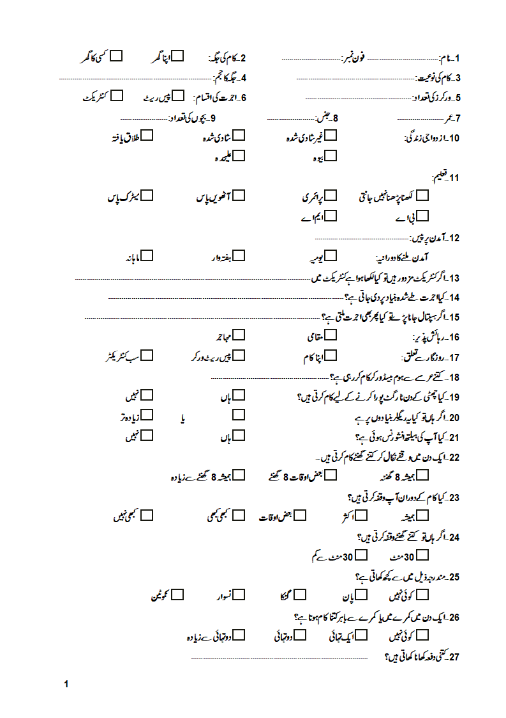
Annex- B
