Training Report on Occupational Safety and Health for Domestic Workers
09-10 Feb, 2021

Overview:
A key goal of the training workshop is to increase the OHS knowledge and skills of the participants and their organizations. Applicants consider a “train-the-trainer” approach that would facilitate the spread of OHS information, skills, and culture to other workers in their community. The Developing World Outreach Initiative (DWOI) and Maquiladora Health and Safety Support Network (MHSSN) jointly initiative from international organizations for small-scale training workshops designed to inform, promote, advance, and build capacity for occupational health and safety (OHS) in economically developing countries.

Participants:
Each meeting will have the following participants:
- 25 Domestic workers
- Master Trainer
- Co-facilitator

Training Material:

- Flip charts
- Markers
- Ball Points
- Note pads
- Folders – folder include following handouts(in same sequence)
- Participants’ training agenda
- Pre-Test Forms
- Training Overview – 1 pager
- Occupational Safety and Health, objectives, impotence and possible precautions during work on workplace.

Objectives:

The capacity training of OSH will enable workers to:
- Learn about the training objectives and activities.
- Importance of occupational safety, health and rights.
- Glimpse on the significance of informal workers
- Importance of hygiene for young girls and women workers.
- Why and how to adopt OSH precautions.

Time and Topic | Method | Description  Day 1 | Day 2 | Required Material
9:30 – 9:45 Registration/ Attendance and  Participants Introduction –  facilitators | Registration Desk  Interactive | Registration Desk  Set up a registration desk at the entrance of the venue.  The co-facilitator will ensure registration with details of each attendee. | Recap | Attendance Sheet (separate copy for each training)
9:45 – 10:00  Pre-Test Forms – Master Trainer and co-facilitator | Filling Forms/Lecture | MT should define the purpose of pre and post training forms.  Share forms with participants and allow 10 min to fill.  After 10 min take each of them and keep all of them with you. | Importance of occupational and safety Health for workers | Post Training Forms / include evaluation part
10:00 – 10:30 Training Overview | Presentation – 20 min  Discussion – 10 min | Project Overview –  Introduction of the organization. | Safety measures of OSH | Presentation Slides or Notes (5 to 6 slides only)
10:30 – 11:00 Importance of Occupational Safety, Health and Rights – Master Trainer | Presentation – 20min  Discussion – 10 min | Understand and discuss Training objectives and activities. | Safety measures of OSH | Presentation Slides or Notes  (10 to 12 slides only)
 | 11:00 – 11:30 Refreshment Break
11:00 – 12:30 | Plenary Group Discussion 30 min  Individual Activity | Occupational Safety, Health and Rights –  Brief about OSH health and rights.  What is OSH and why it is important? | Discussing options to raise community awareness and develop action plans  Identifying options for community mobilization –  Ask the participants that what are their ideas or options that may increase or ensure practices on OSH.  MT shall carry the discussion whereas co-facilitator will write down their ideas on a flip chart in bullet point.  If they come up with any productive ideas, then probe that how they plan to do it.  Individual’s action plans –  Ask them to properly plan their actions what they suggested or about campaign.
12:15 – 12:30  Evaluation– Co-facilitator | Form | - What is health rights?  - hygiene and health rights for workers | Post Training Session forms shall be included separate evaluation section for some random evaluation questioning for their feedback.  All participants should fill and provide back to the project team at same time | Post Training Forms / include evaluation part

Activity Report

Project Title | DWOI
Type of Activity | Occupational Safety and Health Training for Workers
Date of Activity | 09th -10th Feb, 2021 for DWs
Number of participants | 28 Participants

Summary
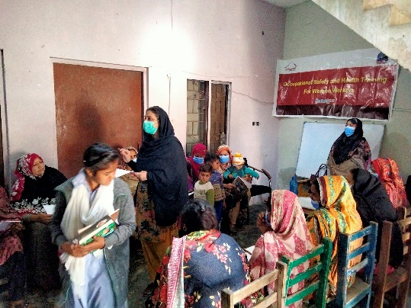

HomeNet Pakistan organized one day training activity for community Domestic workers to make them aware about organizational goals, Awareness on occupational Health and safety, situation during pandemic and role of women workers to attain these safety measures.
The training program was consisted of one day schedule that covered many topics relevant to OSH and women worker role in global pandemic. Program was scheduled as per need of training and to better enhance women workers capacity toward occupational safety and health.
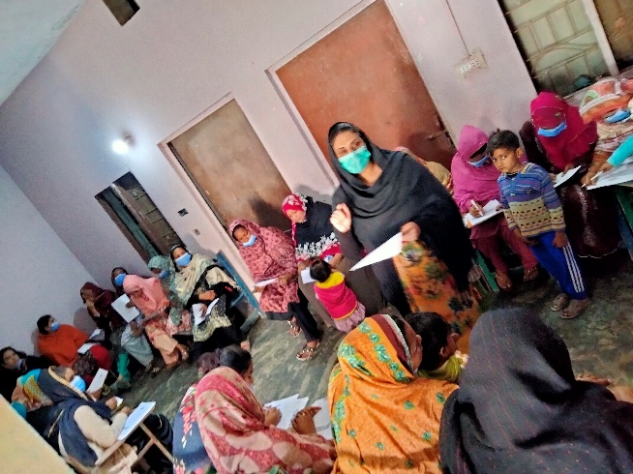
Entire training program was divided into many interactive and participation based activities like brainstorming, interactive lectures, dialogues, discussions, group assignments and presentations that made training more influential, significant and result oriented. Participants remained actively involved throughout the training and participated in each session with interest and valuable contribution. They were also motivated to start interaction with community from the very next day. Their excitement and motivation was showing the above then target achievements in future and created a hope for developing peaceful society through activity participation of women. At the time of closing hygiene kits were distributed to women workers.
Day 1:
Session 1-3: Registration and Introduction
Process:
After registration of DWS for OSH training, facilitator introduced herself. Facilitator divided DWs in two five groups and asked them to introduces each other with one weakness. DWs introduced themselves one by one. They shared their name, work experience, weakness and scope of work. Facilitator distributed pre-test among DWs.

SESSION 4: Training Objectives:
Process:
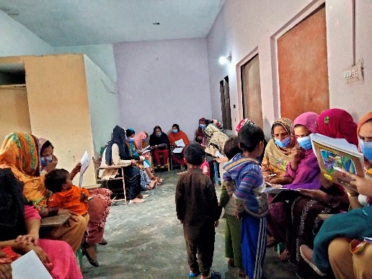
Facilitator gave a detail lecture on objective of training. She said that training workshop is to increase the OHS knowledge and skills of the participants and their organizations. It would facilitate the spread of OHS information, skills, and culture to other workers in their community. Training workshop designed to inform, promote, advance, and build capacity for occupational health and safety (OHS) in economically developing countries.
SESSION 5:
Occupational Safety, Health and Rights:
Process:
Facilitator gave the complete lecture what is occupational safety, health and rights. She divided OSH in three different means. Occupation, Safety, Rights and Health. She said it is stated duty to provide basic health facilities to their citizens. And as an employer it is his/her duty to provide occupational safety to their employees. It is employee rights to avail better health as well as occupational safety from their employers.
SESSION 6: What is health rights? And hygiene and health rights for workers
Process:
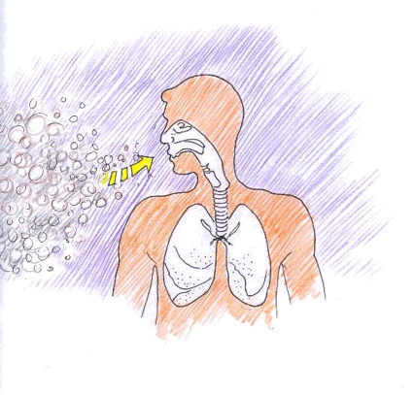
She explained that occupational safety, is a multidisciplinary field concerned with the safety, health, and welfare of people at occupation.
The goal of an occupational safety and health program is to foster a safe and healthy occupational environment. OSH also protects all the general public who may be affected by the occupational environment. In common-law jurisdictions, employers have a common law duty to take reasonable care of the safety of their employees. It was explained that provide pollution free atmosphere to workers for their health.

DAY 2:

Session 1: Recap
Process:
After registration Co-facilitator recap the day first. Most of the participants were well aware about occupational safety and health and training objectives of trainings and OSH rights.
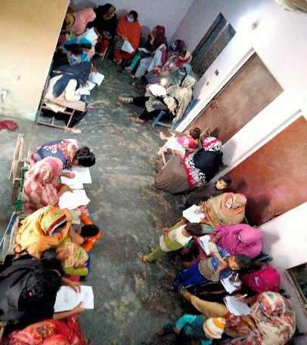
SESSION 2: Importance of occupational and safety Health for workers:
Process:
Facilitator explained why OSH is important and we are organized this training. She gave a detail lecture on importance of OSH. She said the whole objective of Occupational Safety and Health is to prevent diseases, injuries, and deaths that are due to working conditions; no one should have to sue a job related injury or disease because of their employment. Significant changes are constantly occurring in the workplace for example: Longer working hours. Practice Effective Housekeeping: Maintain a clean and organized workplace environment. She said make OSH an ongoing project that everyone is involved in and keep tips in mind: Prevent trips, slips and falls by keeping all floors clean and dry. Eliminate fire hazards by removing combustible materials and storing flammable materials away from sources of ignition. Control dust accumulation.
SESSION 3: Safety measures of OSH
Process:
Facilitator explained safety measures one by one in detail. Workplace safety is an important part of any job and requires that everyone in the company adhere to the safety guidelines and policies in place. Carefully following appropriate safety guidelines can go a long way toward preventing workplace injuries. Here are some ways you can work to stay safe on the job.
Be Aware
Always be alert to what’s happening in your surroundings; remember that your safety is your responsibility. Understand the particular hazards related to your job or workplace, and keep clear of potentially hazardous areas or situations.
Maintain Correct Posture
Use correct posture to protect your back while at work.. The following tips provide information about lifting correctly:
- Use both hands to lift or carry a heavy object.
- Adopt a proper lifting stance by putting the strain on your legs, keeping your back straight and not bending at the waist.
- Wear a back brace for heavy work.
- Test the weight before picking up the item.
- Lift items smoothly and slowly.
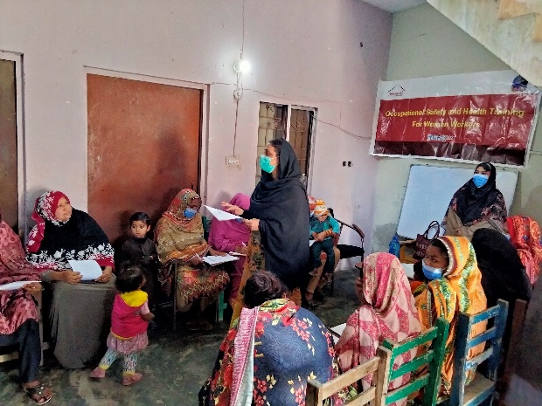
- Move your feet instead of your back when traveling or turning with a heavy object.
- Hold the load close to your body.
- Ask for help to move loads that are too heavy for you.
Take Breaks Regularly
Feeling tired and burned out makes you less likely to be aware of your surroundings and is a common cause of workplace injuries. Regular breaks help you stay fresh and alert on the job. It is particularly important to take short breaks when you have a task that requires repetitive movements over a long period of time.
Use Equipment Properly
Always take the proper precautions when operating machinery or using tools. Taking shortcuts is a leading cause of workplace injuries. Use the appropriate tool for the job, and use it in the right way. When using tools and machinery, put safety first with the following tips: 1.Never place fingers or other objects into moving machinery. 2. Turn off equipment before moving, cleaning, adjusting, oiling or un-jamming.

Locate Emergency Exits: Always know where emergency exits are located and keep the path to them clear. You should also have clear access to emergency shutoffs on machinery.
Report Safety Concerns: If you notice a potential safety hazard or risk, report it to your supervisor immediately so they can address the situation. Keep communication lines open and work as a team to create a safe working environment.
Avoid tracking materials and cross contamination by keeping mats clean and having separate cleaning protocols for different areas. Use appropriate procedures to prevent falling objects. Keep the workplace clutter free. Store all materials and equipment properly. Regularly inspect tools and personal protective equipment to make sure they are in good working order. Make Use of Mechanical Aids. She also said please reduce Workplace Stress. Stress can contribute to difficulty concentrating and depression, which make it hard to be alert at work. Use Appropriate Safety Equipment it is important to use the proper safety equipment for a task to help protect yourself from injury. Wear a breathing masks. It was also explained that creating an environment that is safe is the responsibility of everyone; do your part by following safety guidelines and policies. If you are injured on the job, notify your supervisor immediately and get assistance. Avoid taking risks when it comes to safety, be aware and do your part to maintain a safe workplace environment. If you’ve been injured on the job, call to schedule an appointment to see how our team of specialists can help to get you feeling better and back to work
OutPut/ Outcome
- Motivated, mobilized, aware and trained motivators
- Successful positioning of OSH themes
- Brainstorming on generating innovative ideas for OSH workshops
- 25 women workers aware on Occupational safety and health
- Hygiene kits were distributed among the women workers.
Closing and Evaluation:

Objective:
- To take the feedback of the participants regarding the contents of the course
- To give them certificate of training.
Activity:
Facilitators gave an evaluation sheet to the participants and asked them to write their feedback regarding program contents, training material, facilitators, training methods and also give their general comments about training workshop.
Out Comes:
Participation did the evaluation of the workshop which is described in graphic form.

Evaluation of pre and post analysis:
At the end of the training workshop, HNP team analysis the pre and post analysis of participants.
Questions and analysis of pre and post-test are below;
- What do you know about the training and its objective?
- What do you know about occupational safety and Health?
- Have you ever heard about OSH? If yes, please explain.
- As a worker, how will you mobilize your community on OSH?
- What challenges do you oversee by community? How will you plan to overcome those challenges during work on base of OSH practices?

Pre- test Evaluation:
Topic | fully Aware | Aware | some how | Not aware
What do you know about the training and its objective | 0 | 2 | 6 | 17
What do you know about occupational safety and Health | 0 | 5 | 11 | 14
Have you ever heard about OSH | 0 | 2 | 8 | 15
As a worker, how will you mobilize your community on OSH | 0 | 5 | 5 | 15
challenges during work on base of OSH practices | 0 | 5 | 9 | 10

Post-Test Analysis:
Topic | fully Aware | Aware | some how | Not aware
What do you know about the training and its objective |  | 13 12 | 0 | 0
What do you know about occupational safety and Health | 11 | 14 | 0 | 0
Have you ever heard about OSH | 10 | 14 | 1 | 0
As a worker, how will you mobilize your community on OSH | 9 | 15 | 1 | 0
challenges during work on base of OSH practices | 10 | 13 | 2 | 0

